+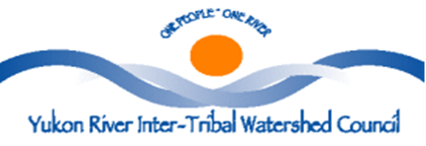
SAFE & SANITARY
DRINKING WATER
PRACTICES MANUAL
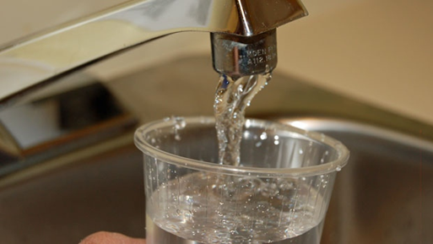

Is this manual for YOU?
If you drink water or provide water for others, this simple manual is designed to give you a basic understanding of the need for safe drinking water and ways to ensure that water used for common domestic purposes is safe drinking water.

We all need for safe drinking water for health and life.

Water is Essential to Life

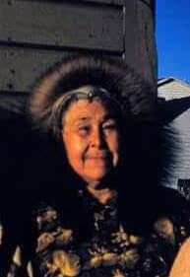
An adequate supply of safe drinking water must be accessible as needed to maintain health and sustain life within the Yukon Watershed.

One cannot live without water. It is a basic human need. Our bodies are made up of 60-70% water. It makes sense then that we look at the water we drink, and how it is handled from its source to its resting place, once it has completed its use in our bodies.
Photo Credit: Pagualak Unagrook, courtesy of Thomas Brower III
Water is our most valuable natural resource. It is essential to all basic human needs, including food, drinking water, sanitation/hygiene, health, energy and shelter. Proper management is the most pressing natural resource challenge of all. Without water we have no society, economy, culture, or life. By its very nature and multiple uses, water is a complex subject.

We cannot properly preserve our water resources without first understanding how water circulates throughout the environment. The water cycle refers to the movement of water on, above, and below the surface of the Earth as ice, snow, liquid, and water vapor. Water constantly moves over or under the ground, evaporates into the atmosphere, mostly through plants, and then recycles as rain or snow.
Every glass of water we drink has, at least already passed through fish, trees, bacteria, soil and many other organisms, including people. As it travels through the ecosystems, it is cleansed for human consumption. The undisturbed natural environment, with a few localized exceptions, provides water that is safe to drink from streams, lakes or wells. This supply of water is a benefit to humans and wildlife that the environment provides.

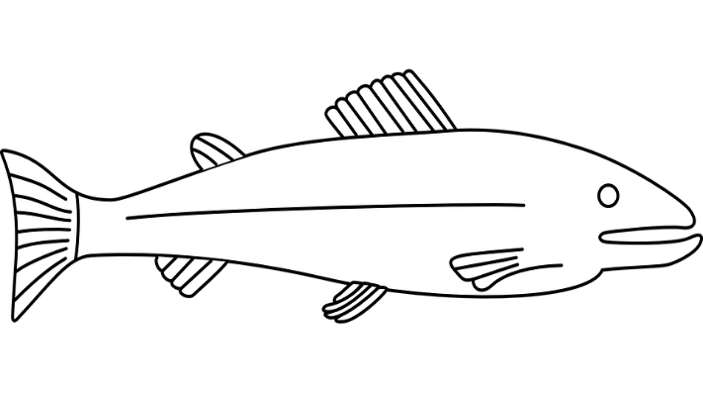
Plants, soils and animals not only sustain the hydrological cycle, they also play a significant role in purifying water. Wetland plants commonly remove high levels of nutrients, such as phosphorous and nitrogen, preventing them from reaching drinking water; many wetland plants can also remove toxic substances, such as heavy metals, from water, accumulating them in their tissues at 100,000 times the concentration in the surrounding water.

Improving the quantity and quality of available safe drinking-water can result in many health benefits. Every effort should be made to achieve drinking-water that is as safe as practicable at all times.
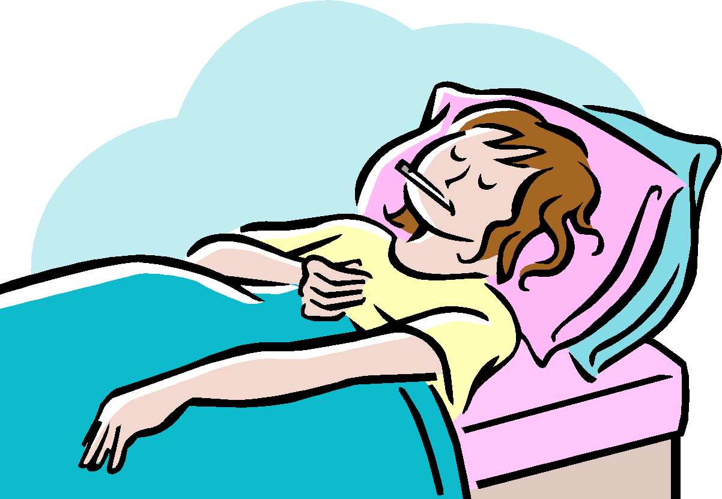
Health risk is elevated by the unclean and/or unsanitary conditions found in any living area lacking running water, piped wastewater services. Infants, Children, Elders are at the greatest risk of harm or illness from waterborne diseases and/or contaminants due to low immune systems. Anyone at risk of waterborne illness need to take additional steps (boiling the water, keep water jugs clean regularly, etc.) to protect themselves against exposure to waterborne pathogens.

Sanitary Practices for Safe Drinking Water
Using water involves many steps. Collection, transportation, storage and use are all stages of using safe drinking water.

Many rural village residents obtain community monitored/treated drinking water from a facility (piped system) into their home faucet. While many residents still obtain water from alternate water sources (pristine streams, lakes) and transport (self-haul) to their home for use. In any case, sanitary practices for proper water hygiene will keep drinking water safely useable and promote the healthy and quality of life for each individual using the water.

The best way to ensure safe drinking water is to prevent contamination once drinking water quality has been established. Proper sanitary practices are the key to maintaining safe drinking water quality.

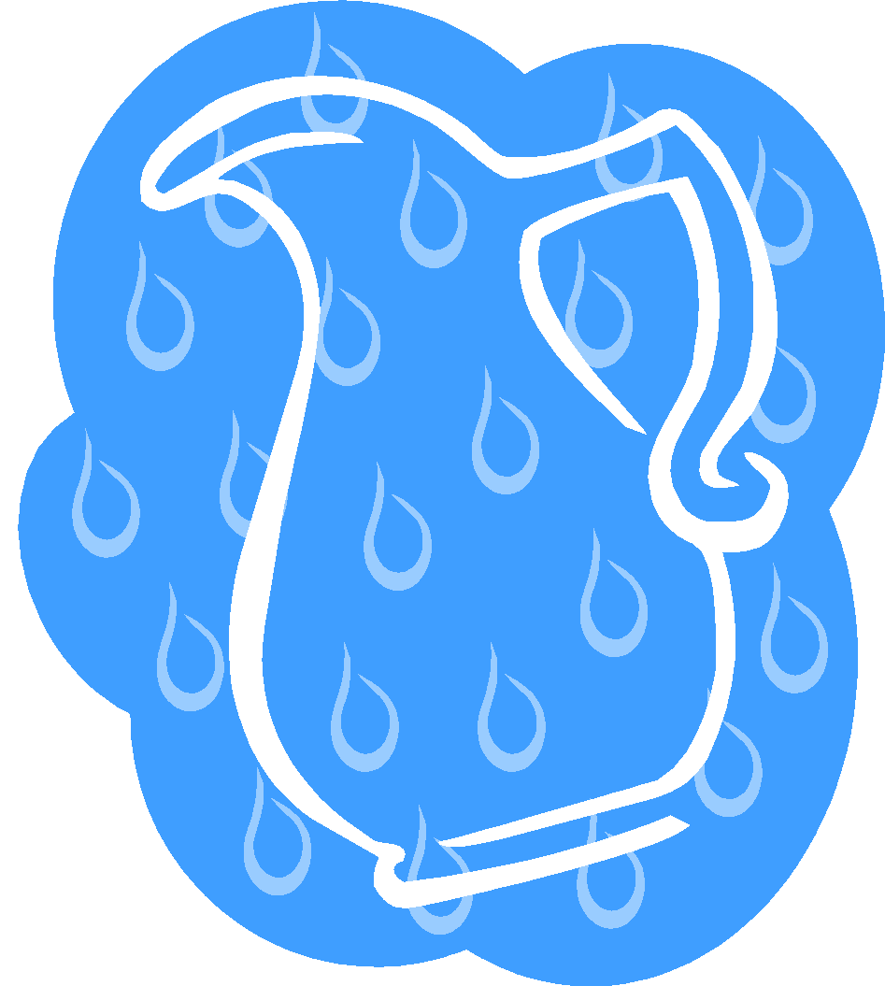
Contaminates may be naturally present at the source or collection point of water. They may also be introduced by a unsanitary utensils (dipper, pail, etc.), containers (bottle, jug, barrel, etc.), transportation devices (pipe, gutter, roof, vehicle, etc.) or any other item (pet, falling debris, etc.) coming into contact with the water being collected for use.

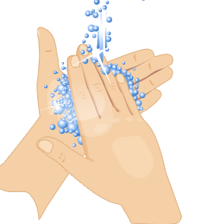
Often, drinking water becomes contaminated through contact from unsanitary utensils, containers or transportation devices/equipment that contain contaminates. All items coming into contact with or in close proximity to drinking water should be sanitized inside and out to prevent possible contamination.

When collecting water from a treated source (Water Facility, community well, school, Washeteria, etc.) it is very important to keep your containers cleansed/sanitized inside and out to prevent contamination from the collection point.

Contamination from a collection point of water source is the surest path to spreading disease throughout a community and/or in a home, impacting the health and safety of infants, children, elders, family and friends.
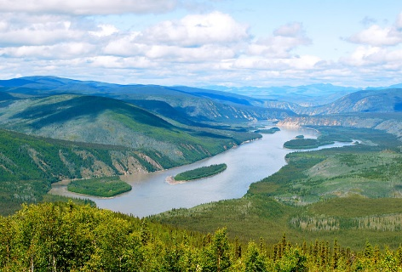
Alternatives Water Sources
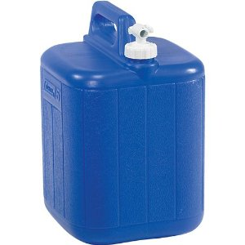
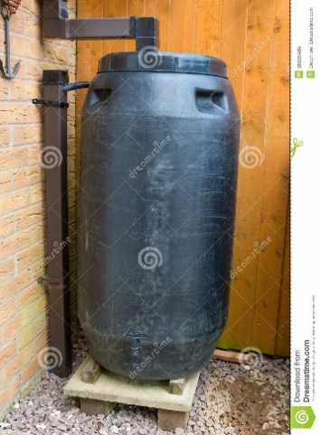
Drinking water can be collected from alternative sources such as from precipitation (rain or snow, etc.), surface water (lake, stream, rain or snow roof runoff, pristine springs, etc.) or ground water (well, springs, etc.). These sources already provide drinking water or the water collected may need to be treated into safe drinking water. Best sanitary practices in keeping utensils, containers and transportation devices free of contaminants will ensure drinking water does not become contaminated and spread diseases that may severely affect the health and safety of infants, children, elderly, and family in the household.
Many households still pack water.
Rain water collection system.

Safe Drinking Water
What is safe drinking water? Adequate safe drinking water which is potable water. Potable water is water which is fit for consumption by humans and other animals, meaning that it does not carry contaminants that threaten health. Water may be naturally potable, as is the case with pristine springs, or it may need to be treated in order to be safe to drink.

Ensuring Safe Drinking Water
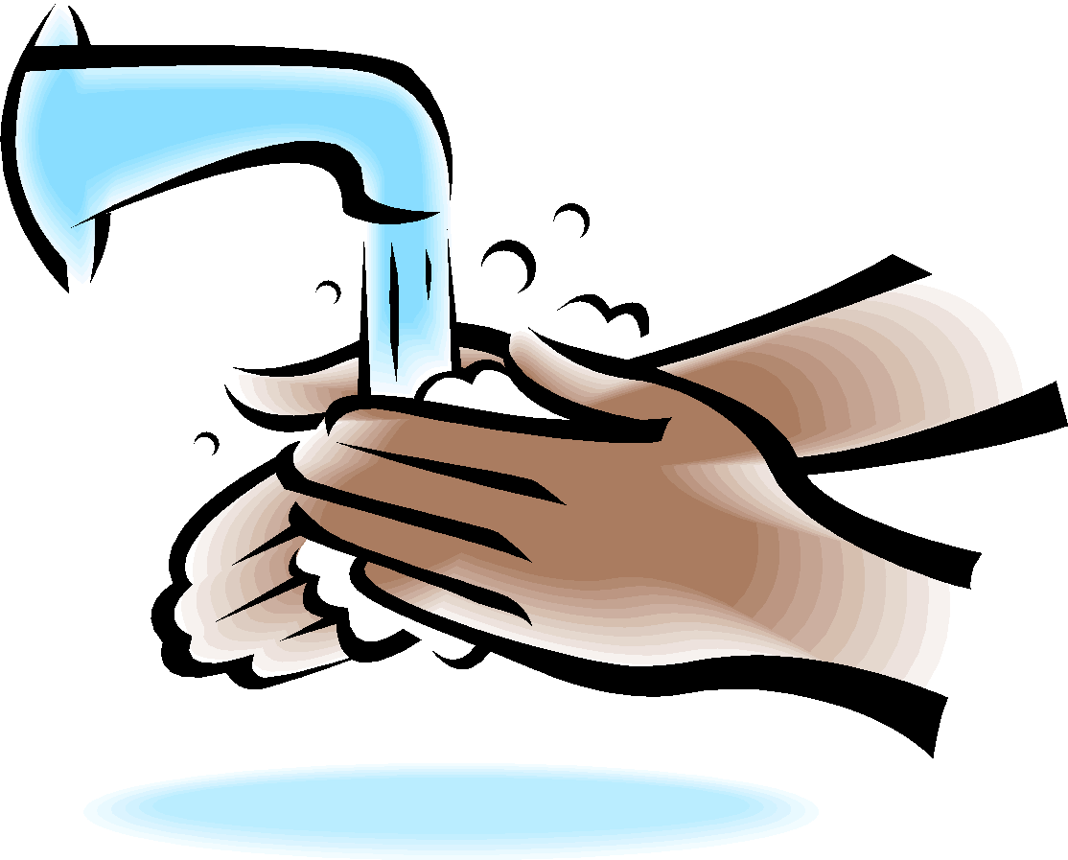
How does one ensure safe drinking water? Testing, monitoring, treatment, sanitary practices and hygiene are the keys to safe drinking water. This is not as difficult as it may sound and you do not have to rely on an outside “expert” to test the water for you, especially if you and your family chooses to access water from an alternative source.

Testing
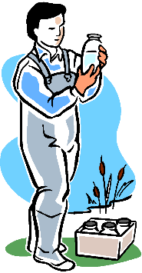
Drinking water supply should be tested on a periodically basis. If water is collected from a known drinking water source (community well, surface water, groundwater school, water plant/Washeteria, etc.) testing and treatment should be performed by the utility system operator on a regular basis and is required by Alaska law. Nonetheless, you may still wish to test your drinking water at the point of use to ensure no contaminants have been introduced between the monitored point of treatment and your point of use. Even water from a monitored, treated source delivered by pipe system to your faucet may become contaminated by the pipes or fixtures (microorganisms, etc.) in your old building.

If you collect water from an unmonitored source you can test the water yourself. This is not a difficult, complex or expensive process and many different home water testing kits are available in large retail stores. Detailed directions for accurate testing are included with these test kits and should be closely followed to obtain accurate results. Example of Drinking Water Test Kit: Product called First Alert (tests to EPA Standards and provides results for: Bacteria, Lead, Pesticides, Nitrates/Nitrites, Chlorine, Hardness and pH).

Threats to Safe Drinking Water
Although water may look clear and clean, there are many substances that may be dissolved that you cannot see. These substances can cause serious health problems. It is vital that you take care to avoid drinking water that has excessive levels of any of the following:
Chemicals (organic and inorganic)
Organic chemicals (petroleum, benzene, dioxin, acrylamide, Benzpyrene, (Benzpyrene is primarily found in gasoline, diesel and exhaust from equipment, cigarette smoke, etc.) may appear from many sources including refuse and waste disposal, community activities, water systems, waste water processing, construction and industrial activities, and/or during fuel transfer.

Inorganic chemicals (minerals and metals, lead, mercury, fluoride, copper, etc.) may result from erosion of natural deposits, corrosion of water handling/processing systems, refuse and waste disposal, industrial and community activities, mining, refining, construction, etc.

Some of these chemicals (lead, mercury, etc.) may contaminate the water after it reaches your location. Older buildings are especially “at risk” for containing hazardous chemicals (lead paint, asbestos) that can potentially contaminate your safe drinking water and pose significant health risks. Removal of lead paint, asbestos from old building should be done by certified contractor.

Not all organic and/or inorganic chemicals need to be removed from water to make it potable. Iron, calcium and sulfur in water may not harm an individual that drinks it but, they can affect the taste of the water. Iron may give the water a reddish-orange appearance; calcium adds to the “hardness” of water creating deposits (bottom of pots where white spots are seen) where evaporation occurs and sulfur causes water to possess an “old, over-boiled egg” odor. Chloride used to treat water for microorganisms may give the water the scent of bleach.

Many chemicals are very dangerous and should never be ingested. Petroleum or its distillates may give the water an oily sheen, feel or taste and a fuel-like scent but, some chemicals are completely undetectable by any of the human senses. Ingestion of these chemicals usually affects an individual’s organs and/or systems, resulting in permanent damage, disability or death.

If you find undesirable levels of a chemical in your water, the treatment process must be tailored to meet the chemical found and the result desired. While you gather the proper information and take the appropriate action to create safe drinking water at your source of water, you should use an alternate proven source for safe drinking water.

Whether you are removing chemicals to make your water potable; filtration is the primary process available. Distillation may remove some chemicals that filtration cannot but, it also usually requires a greater investment to the facility. Some chemicals are very difficult to remove from water and is cost prohibitive to a small rural facility. Protecting the water source from contamination is the best practice.

Lead (Inorganic Chemical): Potential health effects from long term exposure for infants and children can include delays in physical or mental development; slight deficits in attention span and learning disabilities. For adults, problems can include kidney problems and high blood pressure. Maximum Contaminant Level (MCL) allowable 15 ppb (parts per billion). If your water exceeds this level you should immediately take steps to reduce your exposure (see next page).
Threat:
Common sources of lead contamination in drinking water include corrosion of household plumbing or erosion of natural deposits. Lead found in tap water usually comes from older household plumbing, old fixtures, and from the solder that connects pipes (lead based solder was banned in June 1986).

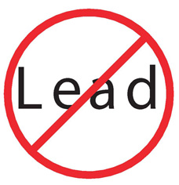
Lead can enter drinking water through corrosion of plumbing materials, especially where the water has high acidity or low mineral content that corrodes pipes and fixtures. Homes built before 1986 are more likely to have lead pipes, fixtures and solder. However, new homes are also at risk: even legally "lead-free" plumbing may contain up to eight percent lead.

Test your home's drinking water for lead
Testing your home's drinking water is the only way to confirm if lead is present. Most piped water systems test for lead at a certain number of homes as a regular part of water monitoring. These tests give a system-wide picture of whether or not corrosion is being controlled but do not reflect conditions at each home served by that water system. Since each home has different plumbing pipes and materials, test results are likely to be different for each home. Communities that are in water & sewer piped system, the service provider does a random selection of homes to do water samples for lead, copper and/or other contaminates. Then the water sample is sent to laboratory for analysis to be done. Once this water sample is received by the community it should be posted in public places and also the city/tribe councils should have this on the agenda for general discussions on the status of the water. Another product in which tribe/city officials can purchase is “First Alert Drinking Water Test Kit” this product test to EPA standards and tests for: Bacteria, Lead, Pesticides, Nitrates, Nitrites, Chlorine, Hardness and pH.
You may want to test your water if:
- your home has lead pipes (lead is a dull gray metal that is soft enough to be easily scratched with a house key), or
- your non-plastic plumbing was installed before 1986.
If your home tests positive for lead:
- Flush your pipes before drinking, and only use cold water for cooking and drinking. Anytime the water in a particular faucet has not been used for six hours or longer, flush your cold-water pipes by running the water until it becomes cold. Contact your water plant operator to verify flushing times for your area.
- Consider replacing lead-containing plumbing fixtures. If you live in an older (pre-1986) home, contact the local housing authority to learn about options for retrofitting lead-containing plumbing fixtures. Keep in mind that the Safe Drinking Water Act (SDWA) requires that only lead-free pipe, solder, or flux may be used in the installation or repair of a public water system, or any plumbing in residential or non-residential facility providing water for human consumption. "Lead-free" under the SDWA means that solders and flux may not contain more than 0.2 percent lead, and pipe, pipe fittings, and well pumps may not contain more than 8.0 percent lead. Beginning January 2014, changes to the Safe Drinking Water Act will further reduce the maximum allowable lead content of pipes, pipe fittings, plumbing fittings, and fixtures to 0.25 percent.
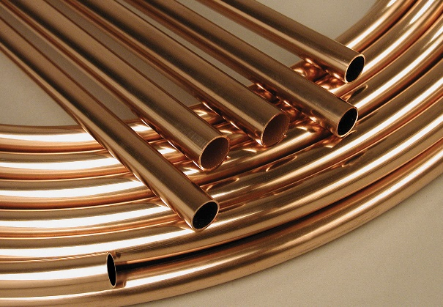
Copper (inorganic chemical): Potential health effects include gastrointestinal distress for brief exposure and the potential for liver or kidney damage for long term exposure. People with Wilson’s Disease, a rare condition that causes too much copper to accumulate in your liver, should consult their personal doctor if the amount of copper in their water exceeds the action level of 1,300 ppb (parts per billion). Common sources of contaminant in drinking water include corrosion of household plumbing and erosion of natural deposits

Test your home's drinking water for copper

Communities that are in water & sewer piped system, the service provider does a random selection of homes to do water samples for lead, copper and/or other contaminates. Then the water sample is sent to laboratory for analysis to be done. Once this water sample is received by the community it should be posted in public places and also the city/tribe councils should have this on the agenda for general discussions on the status of the water.

If your home tests positive for high copper levels:
- Flush the taps prior to drinking: Copper works its way into the water by dissolving from copper pipes in the household plumbing. The longer the water has stood idle in the pipes, the more copper it is likely to have absorbed. (Newer homes with copper pipes may be more likely to have a problem. Over time, a coating forms on the inside of the pipes and can insulate the water from the copper in the pipes. In newer homes, this coating has not yet had a chance to develop.) Thus, anytime the water has not been used for more than six hours-overnight, for example, or during the day when people have been gone to work or school-it should be cleared from the pipes before being used for drinking or cooking. This can be achieved by letting the cold water faucet run until you can feel the water getting colder-usually 30 to 60 seconds. This must be done before taking drinking water from any faucet in the house.
- Draw water for consumption only from the cold water tap: Hot water dissolves copper more quickly than cold water; as a result, water to be used for drinking or cooking should not be drawn from the hot water tap. If you need hot water for cooking or drinking, take water from the cold tap and heat it. It is especially important not to use the hot water for making baby formula.
Benzene:(Organic Chemical) Potential Health effects from long term exposure above the MCL: Anemia; decrease in blood platelets; increased risk of cancer

Common sources of contaminant in drinking water: Discharge from factories; leaching from gas storage tanks and landfills

Maximum Contaminate Level (MCL) allowable 0.005, 5 parts per billion

Public Health Goal: ZERO; Public Safety signs should be posted to keep the children from playing around in the area of the contaminated soils area to protect them from exposure of Benzene.

How will I know if benzene is in my drinking water?
When routine monitoring indicates that benzene levels are above the MCL, your water supplier must take steps to reduce the amount of benzene so that it is below that level. Water suppliers must notify their customers as soon as practical, but no later than 30 days after the system learns of the violation. Additional actions, such as providing alternative drinking water supplies, may be required to prevent serious risks to public health. Each rural Alaska community should know their alternative drinking water source and have protective measures to keep it safe from contaminates.

Where benzene is found and how it is used
- Benzene is formed from both natural processes and human activities.
- Natural sources of benzene include volcanoes and forest fires. Benzene is also a natural part of crude oil, gasoline, and cigarette smoke.

What benzene is
- Benzene is a chemical that is a colorless or light yellow liquid at room temperature. It has a sweet odor and is highly flammable.
- Benzene evaporates into the air very quickly. Its vapor is heavier than air and may sink into low-lying areas.
- Benzene dissolves only slightly in water and will float on top of water.

Asbestos (fibers>10 micrometers): (Inorganic Chemical) Potential Health effects from long term exposure above the Million Fibers per Liter (MFL): Increased risk of developing benign intestinal polyps.

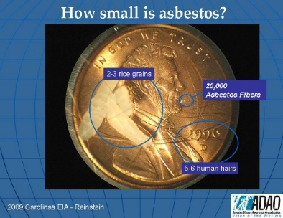
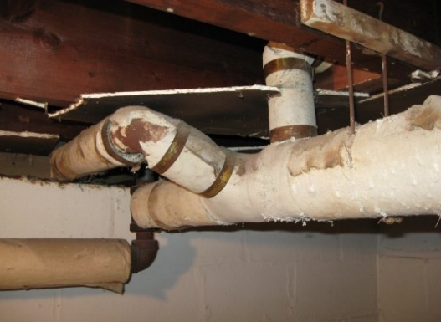
Common sources of contaminant in drinking water: Decay of asbestos cement in water mains (water pipes that are covered with outdated materials); erosion of natural deposits, and old buildings that has asbestos coverings of old water pipes. These should be avoided or disturbed due to asbestos fibers become airborne.

Safe Maximum Contaminate Level (MCL); 7 million fibers per liter (liter is smaller container of a quart container, (Examples below)

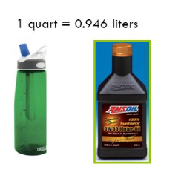

Public Health Goal: 7 Million Fibers per Liter, see penny photo to compare asbestos fiber

Microorganisms (viruses, bacteria, parasites, etc.)
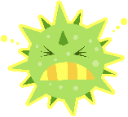
Contaminants in this category may cause relatively well known illnesses, such as Beaver Fever (giardia lamblia), Legionnaire’s Disease (legionella), E. coli (Escherichia coli) viral infections and various parasitic worm infestations. Symptoms may originate in the gastrointestinal system beginning with nausea, cramps, vomiting, diarrhea, dehydration, anemia, etc. and usually require medical treatment. However, some microorganisms will quickly migrate to the blood stream, liver or lungs and initial symptoms may be associated with those areas.
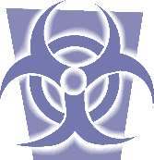
Because microorganisms are generally too small to be seen by the unaided human eye, water that appears clean and clear may still pose a significant health risk.

The general approach to eliminating microorganisms is to disinfect the water. Common disinfectants include boiling the water (at least 1 minute at sea level and at least 3 minutes at altitudes over 3000’) or adding chemical additives (chlorine (bleach), iodine, etc.) that are readily available. Most of the chemicals used to treat water for microorganisms will evaporate with simple aeration (Aeration is the process by which air is circulated through, mixed with or dissolved in a liquid or substance). but, some require special processing. When using a chemical disinfectant process, it is very important to follow the specific directions provided by the manufacturer for that particular product to avoid subsequent chemical contamination.
Particulate matter (organic and inorganic)
Many inactive ingredients may be found suspended in water. They will generally be visible as cloudiness, murky, cloudy, roiled, muddy (turbidity) that can usually be settled or filtered out of the water. The suspension may consist of vegetation, glacial silt or other matter that may not be harmful to consume but, usually affects the taste of the water.

Particulate matter suspended in water will separate rather easily with time. Some of the suspended particulate matter (glacial silt, etc.) will sink to the bottom and other suspended particulate matter (cellulose fibers, etc.) will rise to the surface, depending upon the density of the matter. One may then isolate the clear water for use and dispose of the unwanted material. A quicker method is filtration. Many filtration methods are available that will readily clear water.

WATER TREATMENT
Once you have the water test samples from the testing laboratory and or Alaska Department of Conservation (ADEC), (this test report should be posted to the public) you will know if there are any contaminants that must be removed from your water to have an adequate safe drinking water supply for the community. These contaminants may be broadly grouped as microorganisms, chemicals and particulate matter.

Emergency Disinfection of Drinking Water

In an emergency situation where regular water service has been interrupted – like a flood, or water pipe breakage – local authorities may recommend using only bottled water, boiled water, or disinfected water until regular water service is restored. The instructions below show you how to boil and disinfect water to kill most disease-causing microorganisms that may be present in the water. However, boiling or disinfection will not destroy other contaminants, such as heavy metals, salts, and most other chemicals.
  - Use bottled water or water you have properly prepared and stored as an emergency water supply.
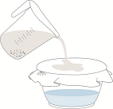
  - Look at the water carefully. How clear is it? Cloudy water is not safe to drink. If water is cloudy, let it settle and filter it through a clean cloth, paper towel, or coffee filter.

- Boil water, if you do not have bottled water. Boiling is sufficient to kill pathogenic bacteria, viruses and protozoa (protozoa a tiny organism whose body is a single cell).
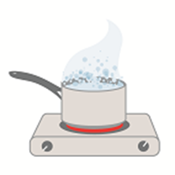
  - Bring water to a rolling boil for at least one minute. At altitudes above 5,000 feet (1,000 meters), boil water for three minutes.
  - Let water cool naturally and store it in clean containers with covers.
  - To improve the flat taste of boiled water, add one pinch of salt to each quart or liter of water, or pour the water from one clean container to another several times.
  - Disinfect water using household bleach, if you can’t boil water. Only use regular, unscented chlorine bleach products that are suitable for disinfection and sanitation as indicated on the label. Do not use scented, color safe, or bleaches with added cleaners. If water is cloudy, let it settle and filter it through a clean cloth, paper towel, or coffee filter.
  - Locate a clean dropper from your medicine cabinet or emergency supply kit.
  - Locate a fresh liquid chlorine bleach or liquid chlorine bleach that is stored at room temperatures for less than one year. The label should say that it contains 8.25% of sodium hypochlorite (bleach).
  - Use the table below as a guide to decide the amount of bleach you should add to the water, for example, add 6 drops of bleach to each gallon of water. Double the amount of bleach if the water is cloudy, colored, or very cold.
  - Stir and let stand for 30 minutes. The water should have a slight chlorine odor. If it doesn’t, repeat the dosage and let stand for another 15 minutes before use.
  - If the chlorine taste is too strong, pour the water from one clean container to another and let it stand for a few hours before use.

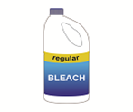
Volume of Water | Amount of Bleach to Add*
1 quart/liter | 2 drops
1 gallon | 6 drops
2 gallons | 12 drops (1/8 teaspoon)
4 gallons | 1/4 teaspoon
8 gallons | 1/2 teaspoon
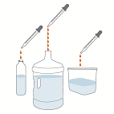
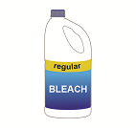

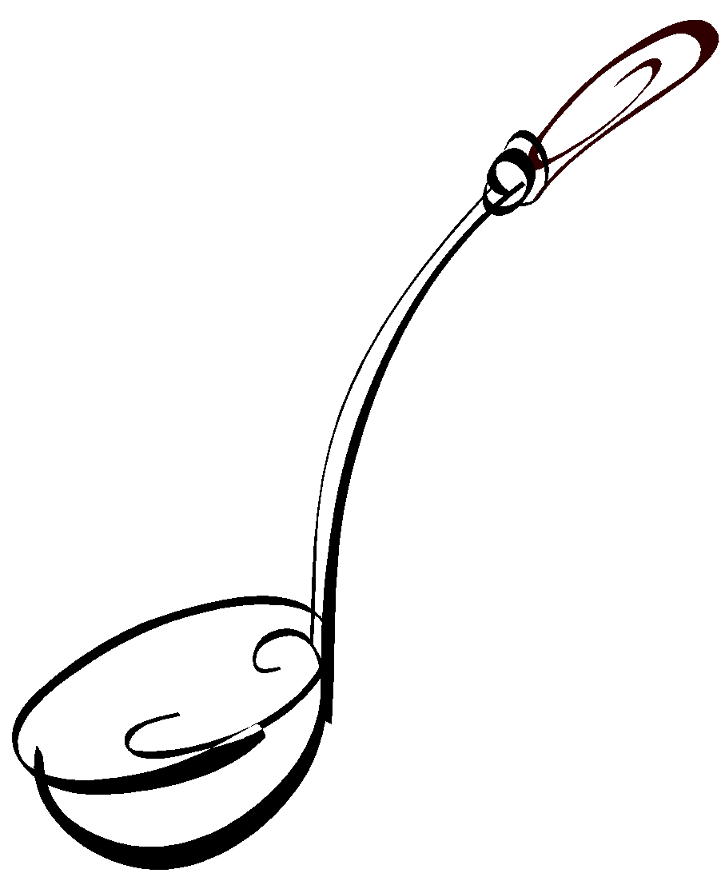Water Tools
Collection, transportation, treatment, storage or use of water generally requires the assistance of tools generally classified as containers. The type of container to be used will be determined by the function it must perform. The function, size, material and even shape of the container can affect its ability to maintain safe water quality. It need not be complex; simple common sense can guide proper container selection.

Barrels, bottles, jugs, etc. are all examples of holding devices. If drinking water will be held for an extended period of time, it should be a container that includes a cover that will prevent airborne or falling contaminants from entering the water. These devices and covers should be constructed of material that will not leak or leach into the water with time. Glass, stainless steel, porcelain, ceramic and some plastics are good materials for this purpose.

If water is to be extracted in single use quantities, an outlet at the bottom should be available to control the release of water without exposing the remaining water to possible contaminants. This avoids the need to dip another item into the water which can easily introduce unseen contaminants into safe drinking water.

If you must use a container that requires dipping to obtain water, keep it covered when the water is not being accessed and always keep the dipping tool far away from any possible contaminants at all times. This includes contact with other items such as insects, animals, hands, used towels, counters, walls, etc. that may harbor contaminates.

Safe Drinking Water Costs
Safe drinking water may take time, effort and even some money. Many times, it may seem to be a boring, inconvenient or troublesome process. In reality, the cost of ensuring safe drinking water quality is quite small and usually need only occur at periodic intervals. When put in perspective, the investment is minimal and the return can be quite substantial. Your health and the health of your family and friends requires adequate safe drinking water.

Contaminated Drinking Water Costs
The cost of safe drinking water is easily calculated in measurements of time, effort and money. The cost of contaminated drinking water may be much higher and more difficult to calculate. How much is your health and safety worth?

For example, one encounter with Beaver Fever may require emergency transportation to a medical facility, treatment with antibiotics and rehydration therapy, days in the hospital, more time at home in bed for recovery, loss of income and productivity, misery, pain, suffering, etc. The list could go on. Now, multiply that “cost” by the number of people served by that water.
Different contaminants affect one’s health differently. Many health effects are permanent. Potential effects of contaminated drinking water include cancer, permanent damage to organs (brain, skin, eyes, liver, kidneys, heart, lungs, thyroid gland, stomach, etc.), permanent systemic damage (reproductive system, immune system, nervous system, circulatory system, digestive system, etc.), hair loss and fingernail loss.

Some pay the ultimate price for using contaminated drinking water, life itself. Infants, children, elderly and anyone with a compromised immune system (those suffering from illness) are at the greatest risk of damage from contaminated water. It becomes quite clear that the cost of safe drinking water is much lower than the eventual cost of unsafe drinking water.

Now, Pass it on!
Tell your family, friends, neighbors and community.
Adequate safe drinking water is for everyone.
Water is Essential to Life

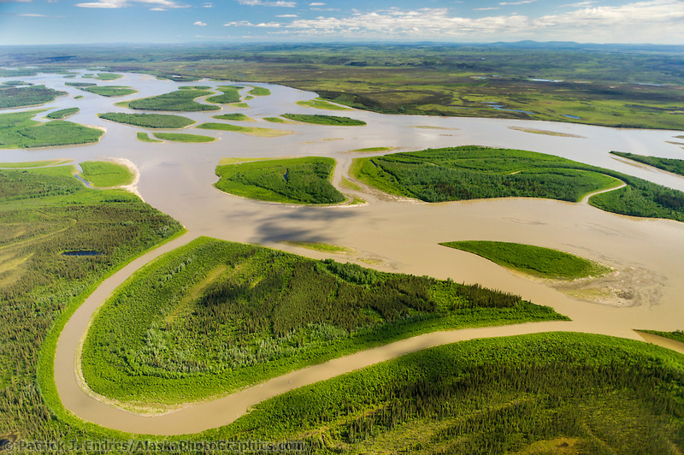
Save our future, preserve our past, protect the infirm and live well.

More Information

If you desire more information regarding adequate safe drinking water, here are a few of the many good web sites available to begin your quest for knowledge.

Alaska Department of Environmental Conservation
http://www.dec.state.ak.us/
DEC-Drinking Water Program Main webpage:
http://dec.alaska.gov/eh/dw/index.htm

DEC-Drinking Water Watch:
http://dec.alaska.gov/DWW/

Drinking Water Program-Fairbanks Compliance Contacts:
1-800-770-2137
1-907-451-2108

DEC-Drinking Water Program General contacts all regions
http://dec.alaska.gov/common/index.htm#dw

Drinking Water Program Engineering Contacts:
http://dec.alaska.gov/eh/docs/dw/Engineering%20Forms/DWEng-Contacts.pdf

Environmental Protection Agency
http://www.epa.gov/

World Health Organization (English language)
http://www.who.int/en/

