`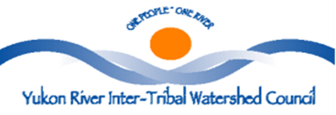
SAFE DRINKING WATER
And
SANITARY
PRACTICES MANUAL FY 19
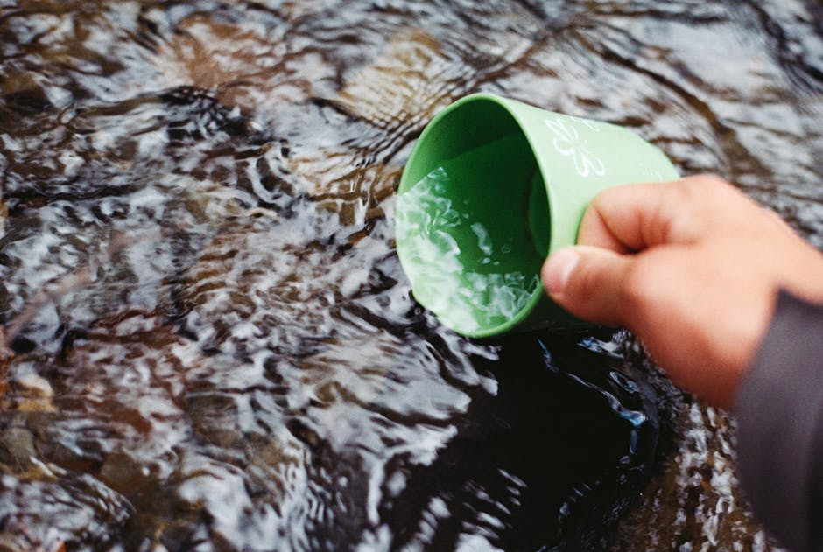

Ability to Drink Clean Water from Yukon River
Is This Manual for YOU!
This manual is designed to give you a basic understanding of the need for safe drinking water and ways to ensure that water used for common domestic purposes is safe clean drinking water. Water sources must be protected at all cost from being contaminated for consumption, uses and for resources we greatly depend on.

Every Living Being needs clean drinking water to sustain healthy life.
Water is Life
Water is Essential to all Life
An adequate supply of safe drinking water must be accessible as needed to maintain health and sustain life within the Yukon Watershed. Water sources must be protected at all cost from contamination (batteries, trash, plastic trash, etc.).

One cannot live without water. It is an essential human need. Our bodies are made up of 60-70% water. It makes sense that we look at the water we drink, and how it is handled from its source to its resting place, once it has completed its use in our bodies.
Protect the Rivers and Streams from actions like these
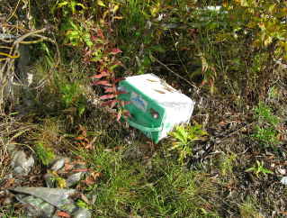
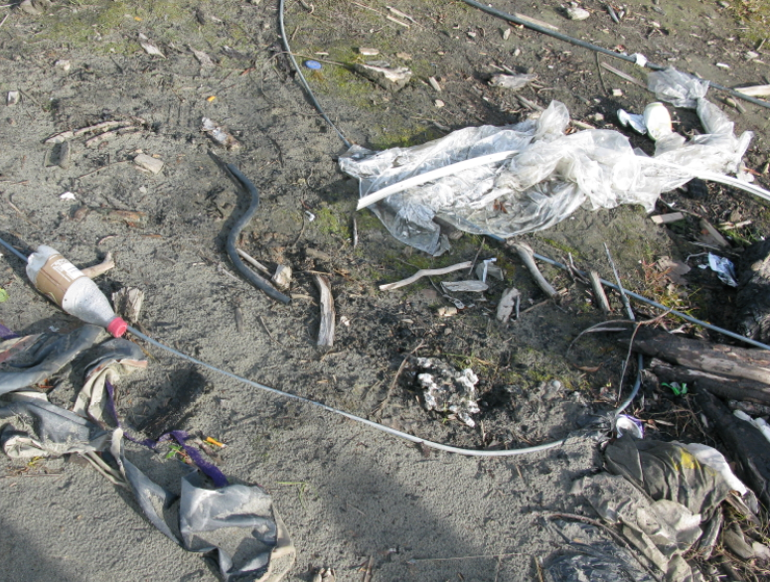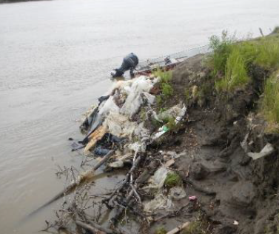

Water is most valuable resource on Earth and should not be taken for granted (do not trash river/stream banks with batteries, and plastic the most dangerous contaminates in the world). It is essential to all basic human needs, including food, drinking water, sanitation/hygiene, health, energy and shelter. Proper management is the most pressing natural resource challenge of all. Without water we have no society, economy, culture, tradition or life. By its very nature and multiple uses, water is a complex subject.
Natural Water Cycle
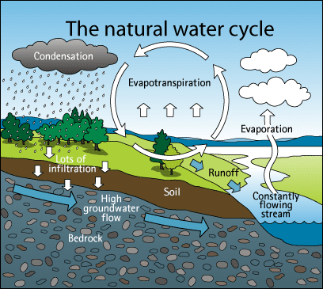
We cannot properly preserve our water resources without first understanding how water circulates throughout the environment. The water cycle refers to the movement of water on above, and below the surface of the Earth as ice, snow, liquid, and water vapor. Water constantly moves over or under the ground, evaporates into the atmosphere, mostly through plants, and then recycles as rain or snow.
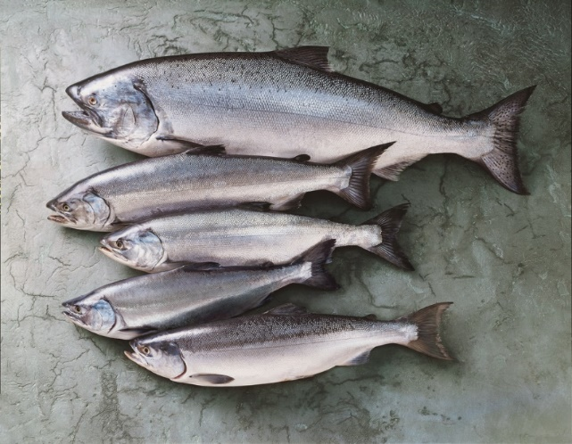
Every ounce of water that has been drank has, at least already passed through fish, animals trees, bacteria, soil and many other organisms, including people. As water travels through the ecosystems, it is cleansed for human consumption. The undisturbed natural environment, with a few localized exceptions, provides water that is safe to drink from streams, lakes or wells. This supply of water is a benefit to humans and wildlife that the environment provides each and every one to sustain life.

Plants, soils and animals not only sustain the hydrological cycle, they also play a significant role in purifying water. Wetland plants commonly remove high levels of nutrients, such as phosphorous and nitrogen, preventing them from reaching drinking water; many wetland plants can also remove toxic substances, such as heavy metals, from water, accumulating them in their tissues at 100,000 times the concentration in the surrounding water.

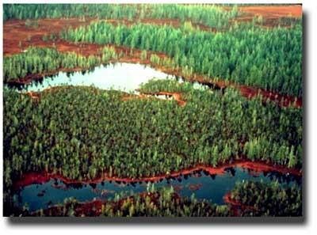
Improving the quantity and quality of available safe drinking-water can result in many health benefits. Every effort should be made to achieve drinking-water that is as safe as practicable at all times, not just for human consumption but for all resources we rely on to practice our traditions, culture activities by harvesting the resources we all depend on to strife.

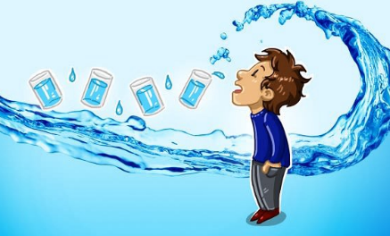
Safe Drinking Water Sanitary Practices for Healthy Life; How to Make Healthy Water
Health risk is elevated by the unclean and/or unsanitary conditions found in any living area lacking running water, piped wastewater services. Infants, Children, Elders are at the greatest risk of harm or illness from waterborne diseases and/or contaminants due to low immune systems. Anyone at risk of waterborne illness need to take additional steps (boiling the water, keep water jugs clean regularly, etc.) to protect themselves against exposure to waterborne pathogens.

Having safe clean water involves many steps. Collection, transportation, storage and usage are all stages of having safe drinking water.

Many rural village residents obtain community monitored/treated drinking water from a facility (piped system) into their home faucet. While many residents still obtain water from traditional water sources (pristine streams, lakes) and/or transport (self-haul) from Water Plants/Washeteria’s (water point to fill containers) to their home for use. In any case, sanitary practices for proper water hygiene will keep drinking water safely useable and promote the healthy and quality of life for each individual using the water.

The best way to ensure safe drinking water is to prevent contamination once drinking water quality has been established. Proper sanitary practices and controlling the waste stream are the key to maintaining safe drinking water quality.

Contaminates may be naturally present at the source or collection point of water. They may also be introduced by unsanitary utensils (dipper, pail, etc.), containers (bottle, jug, barrel, etc.), transportation devices (pipe, gutter, roof, vehicle, etc.) or any other item (pets, falling debris, etc.) coming into contact with the water being collected for use.

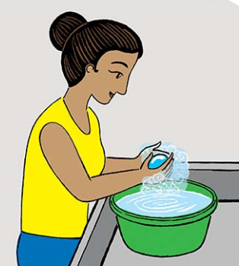
Often, drinking water becomes contaminated through contact from unsanitary utensils, containers or transportation devices/equipment that contain contaminates. All items coming into contact with or in close proximity to drinking water should be sanitized inside and out to prevent possible contaminated water.

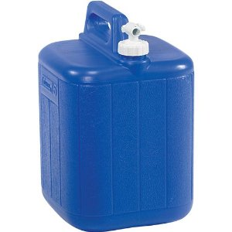
When collecting water from a treated source (Water Facility, community well, school, Washeteria, etc.) it is very important to keep your containers cleansed/sanitized inside and out to prevent contamination from the collection point. Contamination from a collection point of water source is the surest path to spreading disease throughout a community and/or in a home, impacting the health and safety of infants, children, elders, family and friends.
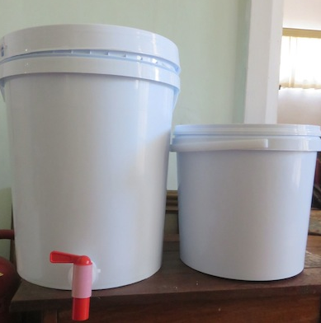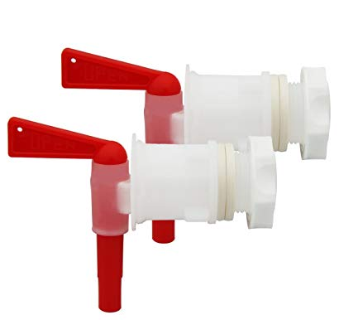

Safe Potable Drinking Water
Potable water: What is potable water?
This is water fit to drink, bathing, dish washing and use in fish tanks. This potable water comes in several types, tap water, mineral water, filtered water and distilled water. Tap water is often treated with trace amounts of anti-bacterial chemicals such as chlorine, chloramine and fluoride by the water company to allow to stay potable for weeks or even months before bacteria has a chance to infect the water. Potable water is actually very rare in terms of water found on earth. It rarely occurs naturally except from some artisan springs. All water must be treated to be made potable by a filter at the very least to a water plant and distillation plant. One of many functions as an water plant operator is maintaining clean working environment which promotes clean healthy water and if your water plant has copper plumbing system advocate to replace plumbing with PEX pipe system which will promote cleaner water and during water sampling no copper or lead will be detected.
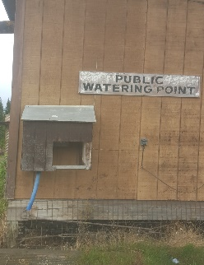
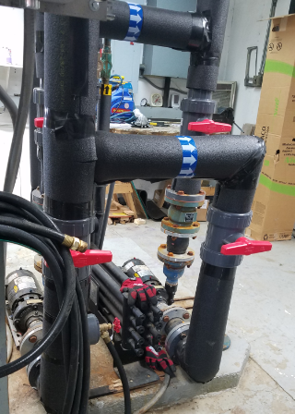
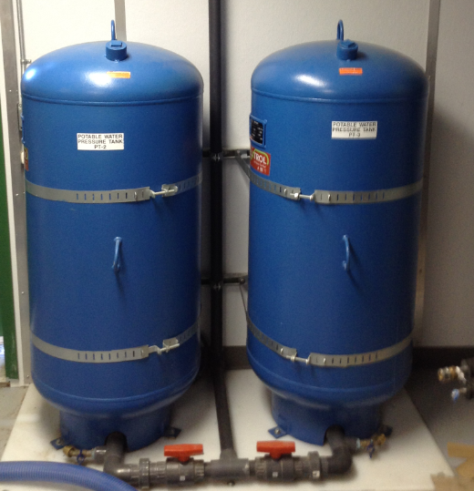

Palatable water: What is palatable water?
Palatable water has a clean, clear appearance with no bad taste or odor. Palatable water has the appearance and presentation of purity, is appealing and desirable to an individual and provides a pleasant, satisfying experience when used.

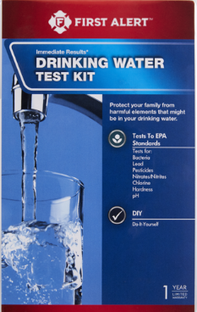
Traditional or Alternative Water Sources
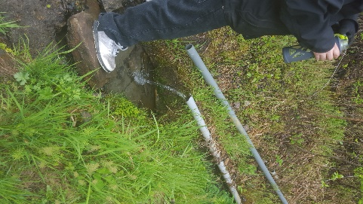
Drinking water can be collected from alternative water sources such as from precipitation (rain or snow, etc.), surface water (lake, stream, rain or snow roof runoff, pristine springs, etc.) or ground water (well, springs, etc.). These sources already provide drinking water or the water collected may need to be treated into safe drinking water. Best sanitary practices in keeping utensils, containers and transportation devices free of contaminants will ensure drinking water does not become contaminated and spread diseases that may severely affect the health and safety of infants, children, elderly, and family in the household.
Water run-off from underground mountain.

Ensuring Safe Drinking Water

How does one ensure safe drinking water? Testing, monitoring, treatment, sanitary practices and hygiene are the keys to safe drinking water. This is not as difficult as it may sound and you do not have to rely on an outside “expert” to test the water for you, especially if you and your family chooses to access water from an alternative source.

Testing
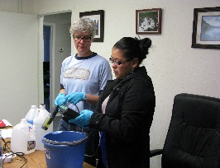
Drinking water supply should be tested on a periodically basis. If water is collected from a known drinking water source (community well, surface water, groundwater school, water plant/Washeteria, etc.) testing and treatment should be performed by the utility system operator on a regular basis and is required by Alaska law. Nonetheless, you may still wish to test your drinking water at the point of use to ensure no contaminants have been introduced between the monitored point of treatment and your point of use. Even water from a
credit, Thomas Brower
monitored, treated source delivered by pipe system to your faucet may become contaminated by the pipes or fixtures (microorganisms, etc.) in your old building.

If you collect water from an unmonitored source you can test the water yourself. This is not a difficult, complex or expensive process and many different home water testing kits are available in large retail stores. Detailed directions for accurate testing are included with these test kits and should be closely followed to obtain accurate results. Example of Drinking Water Test Kit: Product called “First Alert Drinking Water Test Kit” (tests to EPA Standards and provides results for: Bacteria, Lead, Pesticides, Nitrates/Nitrites, Chlorine, Hardness and pH). These test kits can easily be purchased at large retail stores or can be ordered on-line.

Threats
Although water may look clear and clean, there are many substances that may be dissolved that you cannot see. These substances can cause serious health problems. It is vital that you take care to avoid drinking water that has excessive levels of any of the following:
Chemicals (organic and inorganic) Fuel Spills
Organic chemicals (petroleum, benzene, dioxin, acrylamide, Benzpyrene, (Benzpyrene is primarily found in gasoline, diesel and exhaust from equipment, cigarette smoke, etc.) may appear from many sources including refuse and waste disposal, community activities, water systems, waste water processing, construction and industrial activities, and/or during fuel transfer.

Inorganic chemicals (minerals and metals, lead, mercury, fluoride, copper, etc.) may result from erosion of natural deposits, corrosion of water handling/processing systems, refuse and waste disposal, industrial and community activities, mining, refining, construction, abandoned BIA Schools and fuel tanks with flaking lead paint. 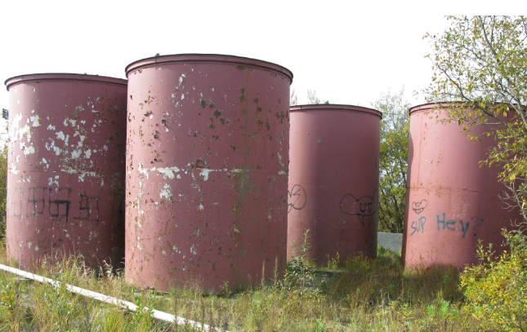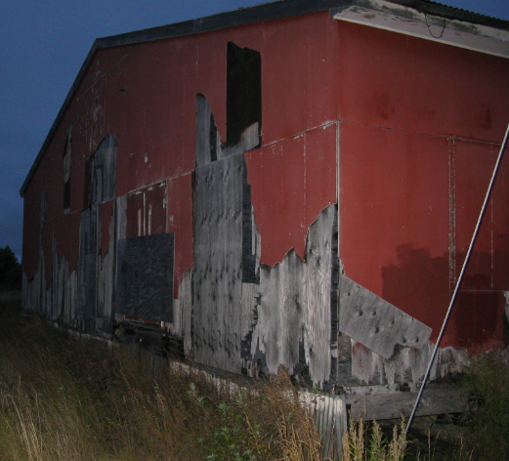

Some of these chemicals (lead, mercury, etc.) may contaminate the water after it reaches your location. Older buildings are especially “at risk” for containing hazardous chemicals (lead paint, asbestos) that can potentially contaminate your safe drinking water and pose significant health risks. Removal of lead paint, asbestos from old building should be done by certified contractor. The lead dust can get into water and soil. People in communities nearby can also be exposed if work is not done right. This means that painters, contractors and other have to take special course that teaches them how to remove paint safely and how to dispose of it properly. Warning Sign’s should be posted to keep children out of these buildings and barracked by blocking the door ways, windows with plywood.

Not all organic and/or inorganic chemicals need to be removed from water to make it potable. Iron, calcium and sulfur in water may not harm an individual that drinks it but, they can affect the taste of the water. Iron may give the water a reddish-orange appearance; calcium adds to the “hardness” of water creating deposits (bottom of pots where white spots are seen) where evaporation occurs and sulfur causes water to possess an “old, over-boiled egg” odor. Chloride used to treat water for microorganisms may give the water the scent of bleach.

Many chemicals are very dangerous and should never be ingested. Petroleum or its distillates may give the water an oily sheen, feel or taste and a fuel-like scent but, some chemicals are completely undetectable by any of the human senses. Ingestion of these chemicals usually affects an individual’s organs and/or systems, resulting in permanent damage, disability or death.

If you find undesirable levels of a chemical in your water, the treatment process must be tailored to meet the chemical found and the result desired. While you gather the proper information and take the appropriate action to create safe drinking water at your source of water, you should use an alternate proven source for safe drinking water.

Whether you are removing chemicals to make your water potable; filtration is the primary process available. Distillation may remove some chemicals that filtration cannot but, it also usually requires a greater investment to the facility. Some chemicals are very difficult to remove from water and is cost prohibitive to a small rural facility. Protecting the water source from contamination is the best practice.

Lead (Inorganic Chemical): Potential health effects from long term exposure for infants and children can include delays in physical or mental development; slight deficits in attention span and learning disabilities. For adults, problems can include kidney problems and high blood pressure.
Threat:
Environmental Protection Agency: 40 CFR Parts 141 and 143: (EPA-HQ-OW-2015-0680, FRL-9958-23-OW), Action: Proposed Rule.
Summary: The EPA proposes to make conforming changes to existing drinking water regulations based on Reduction of Lead in Drinking Water Act of 2011 (RLDWA) and Community Fire Safety Act of 2013 (CFSA). Section 1417 of the Safe Drinking Water Act (SDWA) prohibits the use and introduction into commerce of certain plumbing products that are not lead free. The RLDWA revised the definition of lead free to lower the allowable maximum lead content from 8.0 percent to a weight average of 0.25 percent of the wetted surfaces of plumbing products and established a statutory method for calculating lead content. In addition, the RLDWA created exemptions from lead free requirements for plumbing products that are used exclusively for nonpotable services. The CFSA further amended section 1417 to exempt fire hydrants from these requirements.
EPA proposes to establish new requirements to assure that individuals purchasing, installing or inspecting potable water systems can identify lead free plumbing materials. Specifically, EPA proposes to establish labeling requirements to differentiate plumbing products that meet the lead free requirements from those that are exempt from the lead free requirements and to require manufacturers to certify compliance with the lead free requirements. These proposed requirements would reduce inadvertent use of non-lead free plumbing products in potable use applications and, consequently, reduce exposure to lead in drinking water and associated adverse health effects.
Action: Final Rule will be out in 06/00/2019
Common sources of lead contamination in drinking water include corrosion of household plumbing or erosion of natural deposits. Lead found in tap water usually comes from older household plumbing, old fixtures, and from the solder that connects pipes (lead based solder was banned in June 1986).

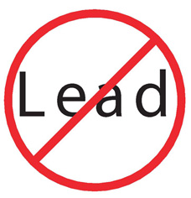
Lead can enter drinking water through corrosion of plumbing materials, especially where the water has high acidity or low mineral content that corrodes pipes and fixtures. Homes built before 1986 are more likely to have lead pipes, fixtures and solder. However, new homes are also at risk: even legally "lead-free" plumbing may contain up to eight percent lead.

Test your home's drinking water for lead
Testing your home's drinking water is the only way to confirm if lead is present. Most piped water systems test for lead at a certain number of homes as a regular part of water monitoring. These tests give a system-wide picture of whether or not corrosion is being controlled but do not reflect conditions at each home served by that water system. Since each home has different plumbing pipes and materials, test results are likely to be different for each home. Communities that are in water & sewer piped system, the service provider does a random selection of homes to do water samples for lead, copper and/or other contaminates. Then the water sample is sent to laboratory for analysis to be done. Once this water sample is received by the community it should be posted in public places and also the city/tribe councils should have this on the meeting agenda for general discussions on the status of the water, after receiving the water sample report
You may want to test your water if:
- your home has old copper piping system installed before 1986 and potentially may have used 50-50 solder which was banned for using in potable water pipes, (lead is a dull gray metal that is soft enough to be easily scratched with a house key), or
- your copper plumbing was installed before 1986. Photo sample below to recognizing a dull gray solder (50/50).
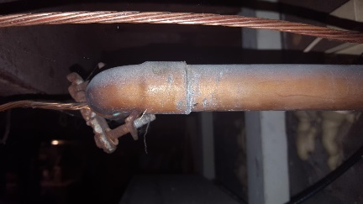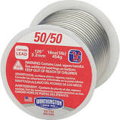
If your home tests positive for lead:
- Flush your pipes before drinking, and only use cold water for cooking and drinking. Anytime the water in a particular faucet has not been used for six hours or longer, flush your cold-water pipes by running the water until it becomes cold. Contact your water plant operator to verify flushing times for your area.
- Consider replacing lead-containing plumbing fixtures. If you live in an older (pre-1986) home, contact the local housing authority to learn about options for retrofitting lead-containing plumbing fixtures. Keep in mind that the Safe Drinking Water Act (SDWA) requires that only lead-free pipe, solder, or flux may be used in the installation or repair of a public water system, or any plumbing in residential or non-residential facility providing water for human consumption. "Lead-free" under the SDWA means that solders and flux may not contain more than 0.2 percent lead, and pipe, pipe fittings, and well pumps may not contain more than 8.0 percent lead. October 2016, changes to the Safe Drinking Water Act was developed: Please visit the web site. EPA Office of Water, October 2016, Lead and Copper Rule Revisions White Paper.
PEX Pipe Vs Copper Pipe, Village Transportation Considerations
Consider replacing with color coded PEX pipe, easy to install, not solder required, use of simple tools. Price comparison 2018 (Lowes, Anchorage, ½ inch by 100 feet red (hot water), blue (cold water) $31.37), Copper ½ inch by 60 ft, $144.21. Home Depot, Anchorage, ½ inch by 100 ft, $33.54 (red), ½ inch by 100 ft, $58.44 (blue), and ½ inch by 20 ft, $74.34. Based on this price comparison using copper pipe can add up to thousands of dollars over the course of a house project. Potential risk using copper pipes fire hazard, use of wrong solder by inexperience plumper.
PEX is also lightweight, flexible, easy to transport and install and built to be long lasting. Like copper, it can carry hot water without melting. There may even be environmental benefits: production, use and disposal of PEX products uses far less energy and produce less carbon dioxide than copper. PEX pipe is much more resistant to freeze-breakage than copper. Benefit to rural Alaska
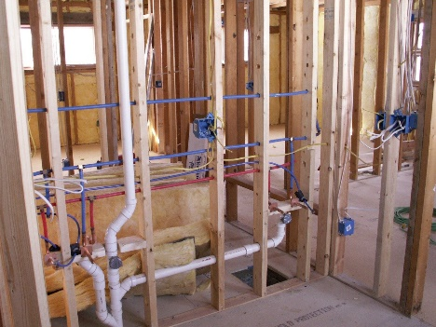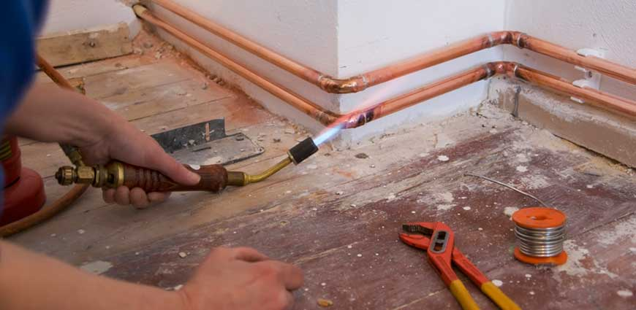
OLD ABANDONED BIA BUILDINGS & OLD BIA FUEL TANKS Dangers of Flaking Lead Based Paint:
Lead has been recognized as a harmful pollutant. In late 1981, the secretary of the Department of Health and Human Services called lead the “number one environmental threat to the health of children in the United States,” There are many ways in which humans are exposed to lead: through air, drinking water, food, contaminated soil, deteriorating paint, and dust. Airborne lead enters the body when individual breathes or swallows lead particles or dust once it has settles. Before it was known how harmful lead could be, it was used in paint, gasoline, water pipes, and many other products
Old lead-based paint is the most significant source of lead exposure in the U.S. today. Most homes built before 1960 contain heavily leaded paint. Some homes built as recently as 1978 may also contain lead paint. This paint could be on window frames, walls, the outside of homes, or other surfaces. Harmful exposures to lead can be created when lead-based paint is improperly removed from surfaces by dry scraping, sanding, or open-flame burning. High concentrations of airborne lead particles in homes can also result from lead dust from outdoor sources, including contaminated soil tracked inside, and use of lead in certain indoor activities such as soldering and stained glass making.
Health Effects of Exposure to Lead
Lead effects practically all systems within the body. At high levels it can cause convulsions, coma, and even death. Lower levels of lead can adversely effect the brain, central nervous system, blood cells, and kidneys
The effects of lead exposure on fetuses and young children can be severe. They include delays in physical and mental development, lower IQ levels, shortened attention spans, and increased behavioral problems. Fetuses, infants, and children are more vulnerable to lead exposure than adults since lead is more easily absorbed into growing bodies, and the tissues of small children are more sensitive to the damaging effects of lead. Children may have higher exposures since they are more likely to get lead dust on their hands and then put their fingers or other lead-contaminated objects into their mouths.
Get your child tested for lead exposure. To find out where to do this, call your doctor or local health clinic. For more information on health effects, get a copy of the Centers for Disease Control’s, Preventing Lead Poisoning in Young Children (October 1991).
Ways to Reduce Exposure to Lead
- Keep areas where children play as dust-free and clean as possible
Mop floors and wipe window ledges as chewable surfaces such as cribs with either a general all-purpose cleaner or a cleaner made specifically for lead. Wash toys and stuffed animals regularly. Make sure that children wash their hands before meals, nap time and bedtime. These practices are important at all times, however, pay special attention during remodeling work.
- Reduce the risk from lead-based paint.
As mentioned above, most homes built before 1960 contain heavily leaded paint, and some homes built as early as 1978 may also contain lead paint. This paint could be on window frames, walls, the outside of homes, or other surfaces. Do not burn painted wood since it may contain lead.
- Leave lead-based paint undisturbed if it is in good condition – do not sand or burn off paint that may contain lead.
Lead paint in good condition is usually not a problem except in places surfaces rub against each other and create dust (for example, opening a window).
- Do not remove lead paint yourself.
Individuals have been poisoned by scraping or sanding lead paint because these activities generate large amounts of lead dust. Consult your state health or housing department for suggestions on which private laboratories or public agencies may be able to help test your home for lead in paint. Home test kits cannot detect small amounts of lead under some conditions. Hire a person with special training for correcting lead paint problems to remove lead-based paint. Occupants, especially children and pregnant women, should leave the building until all work is finished and clean-up is done.
- Do not bring lead dust into the home.
During remodeling, avoid tracking dust from the work area throughout the rest of the home. It is also important to avoid bringing lead in from other sources. If you work in construction, demolition, painting, with batteries, in a radiator repair shop or lead factory, or your hobby involves lead, you may unknowingly bring lead into your home on your hands or clothes. You may also be tracking in lead from soil around your home. Soil very close to homes may be contaminated from lead paint on the outside of the building. Soils by roads and highways may be contaminated from years of exhaust fumes from cars and trucks that used leaded gas. Use door mats to wipe your feet before entering the home. If you work with lead in your job or a hobby, change your clothes before you go home and wash these clothes separately. Encourage your children to play in sand and grassy areas instead of dirt which sticks to fingers and toys. Try to keep your children from eating dirt, and make sure they wash their hands when they come inside.
- Eat right.
A child who gets enough iron and calcium will absorb less lead. Foods rich in iron include eggs, red meats, and beans. Dairy products are high in calcium. Do not store food or liquid in lead crystal glassware or imported or old pottery. If you use old plastic bags to store or carry food. Keep the printing on the outside of the bag.
More Information
- Contact the National Lead Information Center call and speak with a specialist Monday through Friday, 8:00 am to 6:00 pm eastern time (except Federal holidays) at 1 (800) 424-LEAD (5323). The Hotline provides a basic information packet on lead in English. The EPA website contains additional information on where lead can be found and how to protect your family.
- Alaska, Please note that these contacts are able to assist with work-related lead exposure questions only. If you have other public health-related questions, please contact the CDC Infoline at 800-CDC-INFO, (800-232-4636). Alaska Department of Health and Social Services website at: dhss.alaska.gov

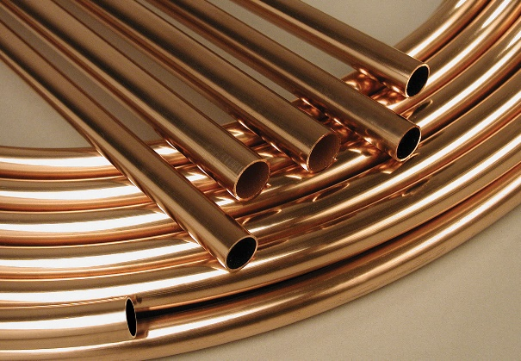
Copper (inorganic chemical): Potential health effects include gastrointestinal distress for brief exposure and the potential for liver or kidney damage for long term exposure. People with Wilson’s Disease, a rare condition that causes too much copper to accumulate in your liver, should consult their personal doctor if the amount of copper in their water exceeds the action level of 1,300 ppb (parts per billion). Common sources of contaminant in drinking water include corrosion of household plumbing and erosion of natural deposits

Test your home's drinking water for copper

Communities that are in water & sewer piped system, the service provider does a random selection of homes to do water samples for lead, copper and/or other contaminates. Then the water sample is sent to laboratory for analysis to be done. Once this water sample is received by the community it should be posted in public places and also the city/tribe councils should have this on the agenda for general discussions on the status of the water.

If your home tests positive for high copper levels:
- Flush the taps prior to drinking: Copper works its way into the water by dissolving from copper pipes in the household plumbing. The longer the water has stood idle in the pipes, the more copper it is likely to have absorbed. (Newer homes with copper pipes may be more likely to have a problem. Over time, a coating forms on the inside of the pipes and can insulate the water from the copper in the pipes. In newer homes, this coating has not yet had a chance to develop.) Thus, anytime the water has not been used for more than six hours-overnight, for example, or during the day when people have been gone to work or school-it should be cleared from the pipes before being used for drinking or cooking. This can be achieved by letting the cold water faucet run until you can feel the water getting colder-usually 30 to 60 seconds. This must be done before taking drinking water from any faucet in the house.
- Draw water for consumption only from the cold water tap: Hot water dissolves copper more quickly than cold water; as a result, water to be used for drinking or cooking should not be drawn from the hot water tap. If you need hot water for cooking or drinking, take water from the cold tap and heat it. It is especially important not to use the hot water for making baby formula.
Benzene:(Organic Chemical) The Maximum contaminate level goals (MCLG) for Benzene is zero. EPA has set this level of protection based on the best available science to prevent potential health problems. EPA has set an enforceable regulation for benzene, called a Maximum Contaminate Level (MCL) at 0.005 parts per billion. MCLs are set as close to the health goals as possible, considering cost, benefits and the ability of public water systems to detect and remove contaminates using suitable treatment technologies.
Public Health Goal: ZERO; Public Safety signs should be posted to keep the children from playing around old fuel tanks in the area of the contaminated soils area to protect them from exposure of Benzene.
Common sources of contaminant in drinking water: Discharge from factories; leaching from gas storage tanks and landfills.

How will I know if benzene is in my drinking water?
When routine monitoring indicates that benzene levels are above the MCL, your water supplier must take steps to reduce the amount of benzene so that it is below that level. Water suppliers must notify their customers as soon as practical, but no later than 30 days after the system learns of the violation. Additional actions, such as providing alternative drinking water supplies, may be required to prevent serious risks to public health. Each rural Alaska community should know their alternative drinking water source and have protective measures to keep it safe from contaminates.

Where benzene is found and how it is used
- Benzene is formed from both natural processes and human activities.
- Natural sources of benzene include volcanoes and forest fires. Benzene is also a natural part of crude oil, gasoline, and cigarette smoke.

What benzene is
- Benzene is a chemical that is a colorless or light yellow liquid at room temperature. It has a sweet odor and is highly flammable.
- Benzene evaporates into the air very quickly. Its vapor is heavier than air and may sink into low-lying areas.
What happens to benzene when it enters the environment?
Benzene is commonly found in the environment. Industrial processes are the main source of benzene in the environment. Benzene levels in the air can be elevated by emissions from burning coal and oil, benzene waste and storage operations, motor vehicle exhaust, and evaporation from gasoline service stations. Tobacco smoke is another source of benzene in air, particularly smoking indoors. Families are encouraged not to smoke in their house, in enclosed environments, or near their children. Industrial discharge, disposal of products containing benzene, and gasoline leaks from underground storage tanks release benzene into water, and soil breaks down more slowly. Benzene is slightly soluble in water and can pass through the soil into underground water. Benzene in the environment does not build up in plants or animals.
Living near gasoline fueling stations or hazardous waste sites may increase exposure to benzene. People are advised not to have their children/families play near fueling stations, manufacturing plants or hazardous waste sites.
Prevent and Cleanup Spills
One of the best practice to prevent contamination to water source is to prevent spills, and clean up the site “As Soon as Possible” even if it is couple of gallons, Why? It’s the law!
Threats
Fuel Stands for Flood Prone Areas and Fuel Leaks from fuel Tanks that are not maintained
Yukon River Basin has many flood prone communities and has experienced these floods and will continue to do so. The floods are unavoidable when there is ice jams or flash floods from accelerated snow melt.
- Flash flooding and ice jams are a fact of life in many parts of Alaska
- Unanchored heating oil tanks can be easily moved during flask floods and ice jams
- Floating tanks can cause serious damage to buildings and the environment
Secure Fuel Tanks and Hazardous Materials
Above-ground fuel tanks are common throughout Alaska. Earthquakes and floods sometimes cause tanks to fall or float from their supporting structures. Drinking water supplies often become contaminated and community recovery may be significantly delayed. Accidental releases of other hazardous materials also can cause serious health, safety and environmental problems during and after disasters. Fortunately, simple mitigation measures can reduce or eliminate most of these problems. Secure the chemicals in locked containers to avoid toxic mixture during and after flood.
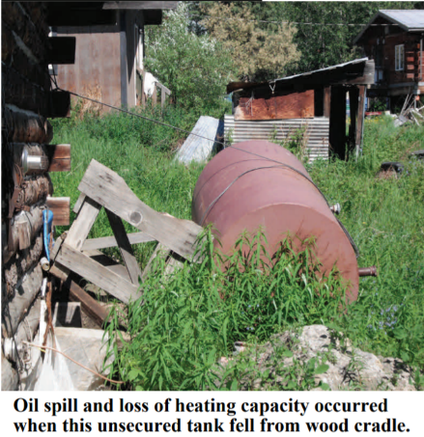
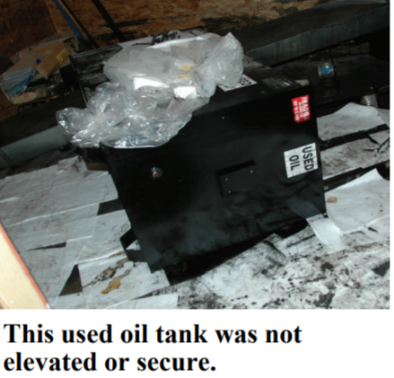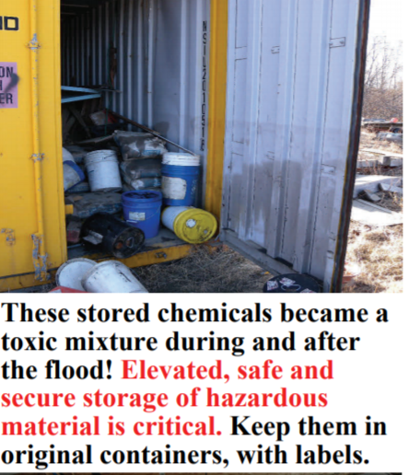
Types of Support Structures
There are three main types of tank support structures that are found in Alaska: hand-built wood support, timber cradle support and fabricated steel support systems.

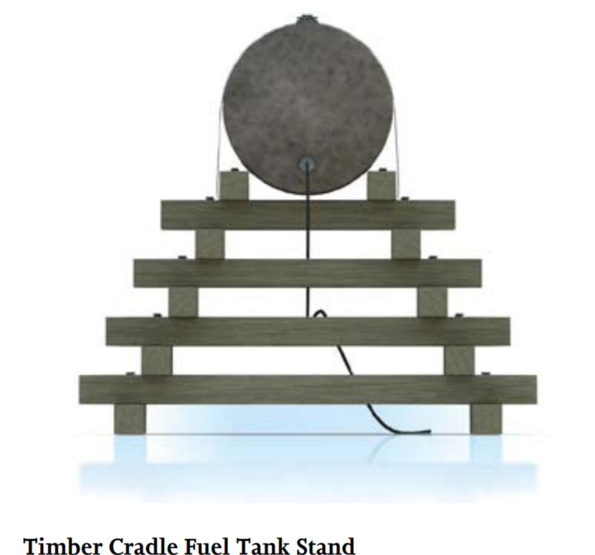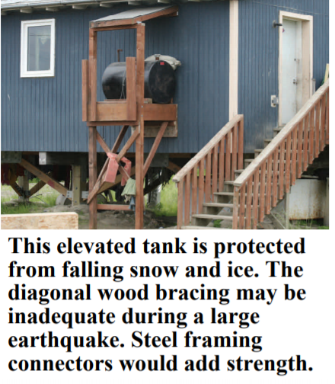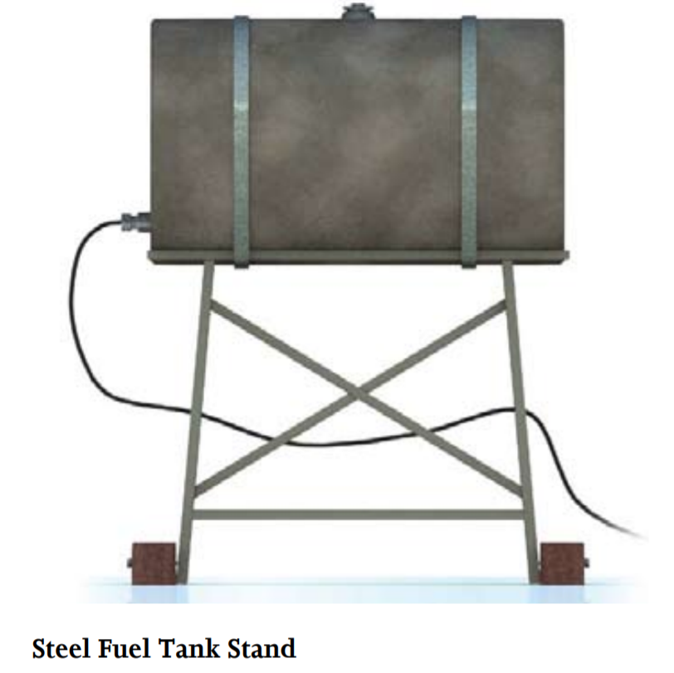

Leaks and small spills are very common—consider adding a containment area under the tank with a soil or sand berm and fuel resistant liner
One gallon of spilled oil can contaminate over 1 million gallons of fresh water!
Build Stronger, Safer, Smarter to prevent accidental release Fuel and Chemical Storage Requires an extra Level of Care

Causes and Corrections
- Overfills
- Sudden Accidents
- Kids climbing on tanks, lines and filters
- Vehicles run into tanks or exposed lines
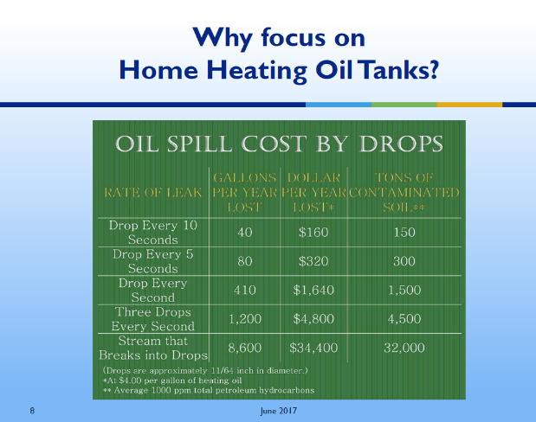
- Bears stretch out on tanks
- Moose step on exposed lines
- Vandalism/Theft
- Earthquakes/Floods
- Most of these causes are preventable if you routinely:
Inspect & Correct = cash/dollars
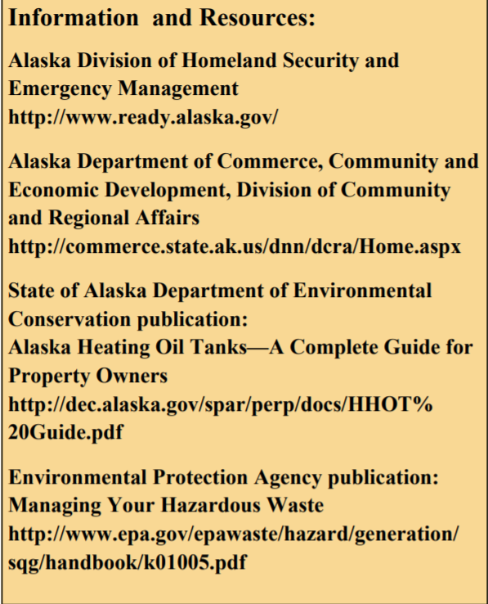
Credit of FEMA, State of Alaska, Department of Military and Veterans Affairs, Homeland Security & Emergency Management.
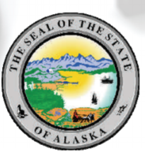

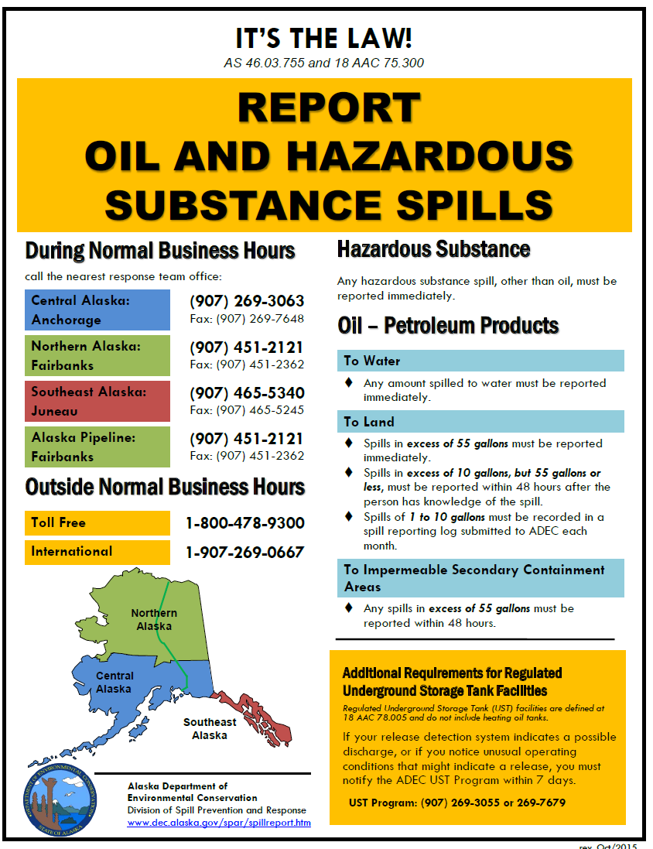
Please remove poster in the back of manual and post it in Public place

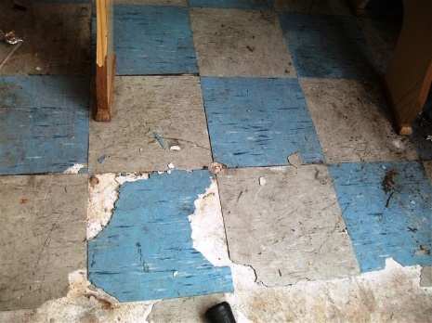
Asbestos (fibers>10 micrometers): (Inorganic Chemical) Potential Health effects from long term exposure above the Million Fibers per Liter (MFL): Increased risk of developing benign intestinal polyps.

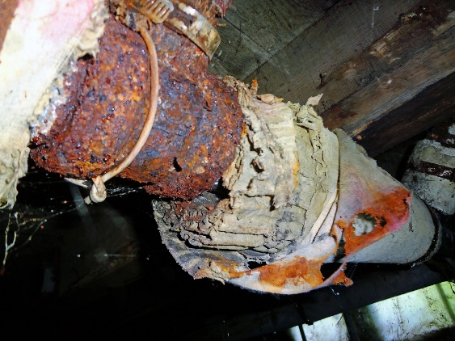
Common sources of contaminant in drinking water: Decay of asbestos cement in water mains (water pipes that are covered with outdated materials); erosion of natural deposits, and old buildings that has old asbestos based vinyl floor tiles, coverings of old water pipes. These should be avoided or disturbed due to asbestos fibers become airborne.

Safe Maximum Contaminate Level (MCL); 7 million fibers per liter, this is the Public Health Goal, if there is a suspect of asbestos in an old home, consult with Health Department Provider and/or community housing department with the community, so an expert can evaluate your home.
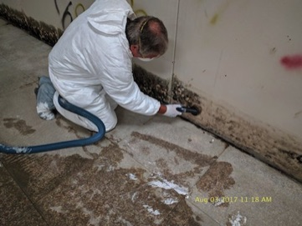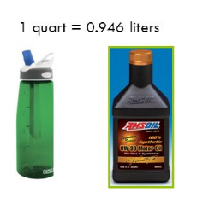

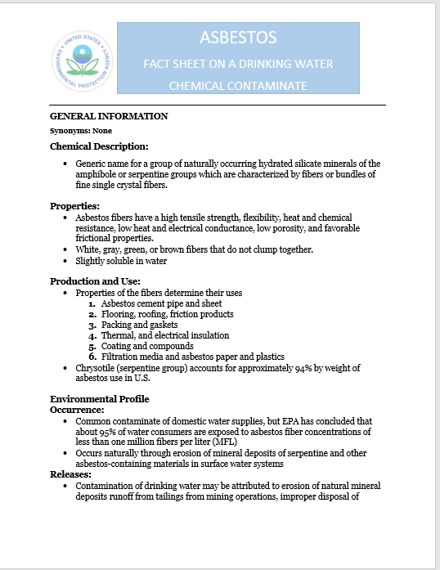

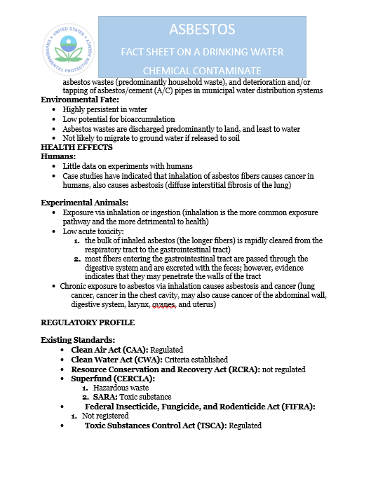
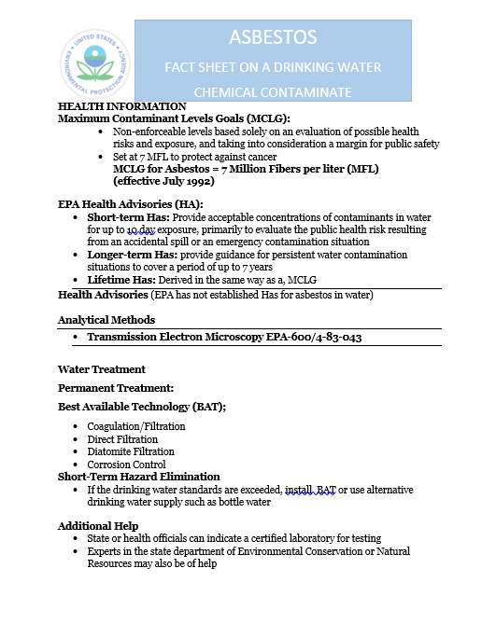
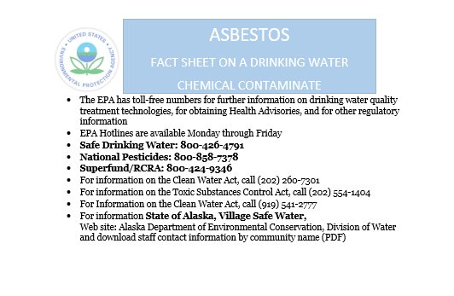
Thanks to EPA for valuable information on Asbestos Fact Sheet on a drinking water chemical contaminate

Microorganisms (viruses, bacteria, parasites, etc.)
Contaminants in this category may cause relatively well known illnesses, such as Beaver Fever (giardia lamblia), Legionnaire’s Disease (legionella), E. coli (Escherichia coli) viral infections and various parasitic worm infestations. Symptoms may originate in the gastrointestinal system beginning with nausea, cramps, vomiting, diarrhea, dehydration, anemia, etc. and usually require medical treatment. However, some microorganisms will quickly migrate to the blood stream, liver or lungs and initial symptoms may be associated with those areas.
Because microorganisms are generally too small to be seen by the unaided human eye, water that appears clean and clear may still pose a significant health risk.

The general approach to eliminating microorganisms is to disinfect the water. Common disinfectants include boiling the water (at least 1 minute at sea level and at least 3 minutes at altitudes over 3000’) or adding chemical additives (chlorine (bleach), iodine, etc.) that are readily available. Most of the chemicals used to treat water for microorganisms will evaporate with simple aeration (Aeration is the process by which air is circulated through, mixed with or dissolved in a liquid or substance). but, some require special processing. When using a chemical disinfectant process, it is very important to follow the specific directions provided by the manufacturer for that particular product to avoid subsequent chemical contamination.
Particulate matter (organic and inorganic)
Many inactive ingredients may be found suspended in water. They will generally be visible as cloudiness, murky, cloudy, roiled, muddy (turbidity) that can usually be settled or filtered out of the water. The suspension may consist of vegetation, glacial silt or other matter that may not be harmful to consume but, usually affects the taste of the water.

Particulate matter suspended in water will separate rather easily with time. Some of the suspended particulate matter (glacial silt, etc.) will sink to the bottom and other suspended particulate matter (cellulose fibers, etc.) will rise to the surface, depending upon the density of the matter. One may then isolate the clear water for use and dispose of the unwanted material. A quicker method is filtration. Many filtration methods are available that will readily clear water.

WATER TREATMENT
Once you have the water test samples from the testing laboratory and or Alaska Department of Conservation (ADEC), (this test report should be posted to the public) you will know if there are any contaminants that must be removed from your water to have an adequate safe drinking water supply for the community. These contaminants may be broadly grouped as microorganisms, chemicals and particulate matter.

Emergency Disinfection of Drinking Water

In an emergency situation where regular water service has been interrupted – like a flood, or water pipe breakage – local authorities may recommend using only bottled water, boiled water/boil water notice, or disinfected water until regular water service is restored. The instructions below show you how to boil and disinfect water to kill most disease-causing microorganisms that may be present in the water. However, boiling or disinfection will not destroy other contaminants, such as heavy metals, salts, and most other chemicals.
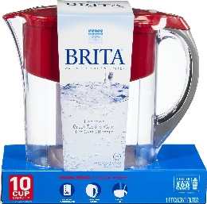
  - Use bottled water or water you have properly prepared and stored as an emergency water supply.
  - Look at the water carefully. How clear is it? Cloudy water is not safe to drink. If water is cloudy, let it settle and filter it with a Brita and/or through a clean cloth, paper towel, or coffee filter.
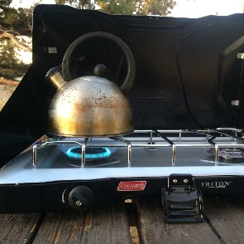
- Boil water, if you do not have bottled water. Boiling is sufficient to kill pathogenic bacteria, viruses and protozoa (protozoa a tiny organism whose body is a single cell).
  - Bring water to a rolling boil for at least for three minutes.
  - Let water cool naturally and store it in clean containers with covers.
  - To improve the flat taste of boiled water, add one pinch of salt to each quart or liter of water, or pour the water from one clean container to another several times.
  - Disinfect water using household bleach, if you can’t boil water. Only use regular, unscented chlorine bleach products that are suitable for disinfection and sanitation as indicated on the label. Do not use scented, color safe, or bleaches with added cleaners. If water is cloudy, let it settle and filter it through a clean cloth, paper towel, or coffee filter.
  - Locate a clean dropper from your medicine cabinet or emergency supply kit.
  - Locate a fresh liquid chlorine bleach or liquid chlorine bleach that is stored at room temperatures for less than one year. The label should say that it contains 8.25% of sodium hypochlorite (bleach).
  - Use the table below as a guide to decide the amount of bleach you should add to the water, for example, add 6 drops of bleach to each gallon of water. Double the amount of bleach if the water is cloudy, colored, or very cold.
  - Stir and let stand for 30 minutes. The water should have a slight chlorine odor. If it doesn’t, repeat the dosage and let stand for another 15 minutes before use.
  - If the chlorine taste is too strong, pour the water from one clean container to another and let it stand for a few hours before use.
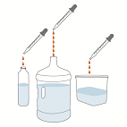
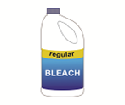
Volume of Water | Amount of Bleach to Add*
1 quart/liter | 2 drops
1 gallon | 6 drops
2 gallons | 12 drops (1/8 teaspoon)
4 gallons | 1/4 teaspoon
8 gallons | 1/2 teaspoon
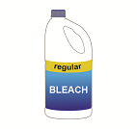

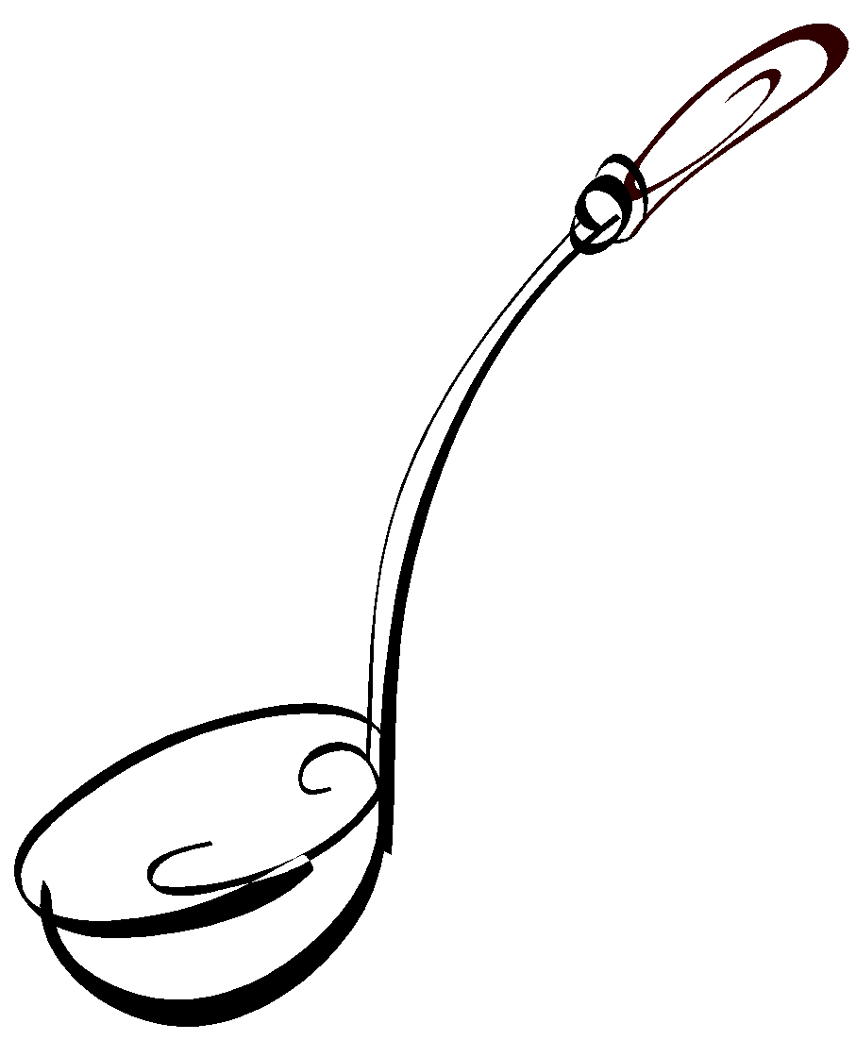Water Tools 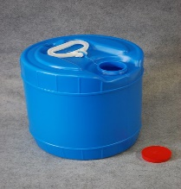
Collection, transportation, treatment, storage or use of water generally requires the assistance of tools generally classified as containers. The type of container to be used will be determined by the function it must perform. The function, size, material and even shape of the container can affect its ability to maintain safe water quality. It need not be complex; simple common sense can guide proper container selection.

Fact Sheet
Water storage tank requirements by, State of Alaska, Department of Environmental Conservation for Alaska water storage tanks. Periodic maintenance is required for storage tank, itself. Materials that is too small to be removed during the treatment process will enter the tank. In time, these fine particles settle out of the water forming a layer of sediment at the bottom of the tank that must be removed. Examples of sediments:
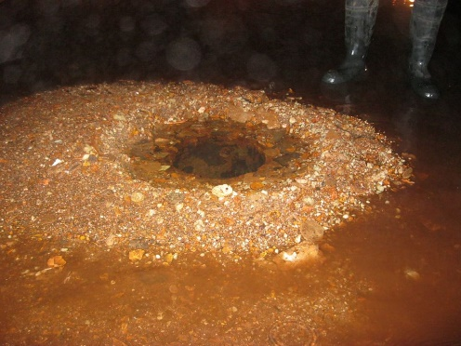
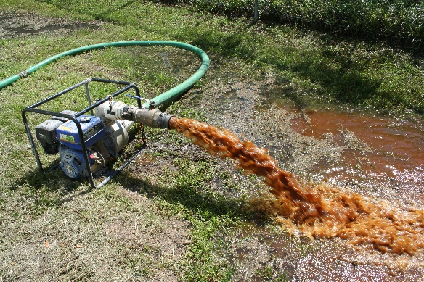
Importance of cleaning the water storage tank, the taste of water might taste rusty, and will clog up the water plants filtration system more frequently, thus creating costly maintenance. Cleaning intervals of the water storage tank will vary depending on the quality of water being treated and efficiency of the treatment process.
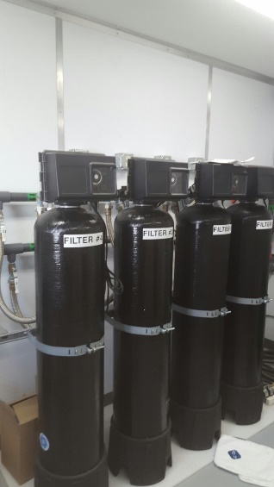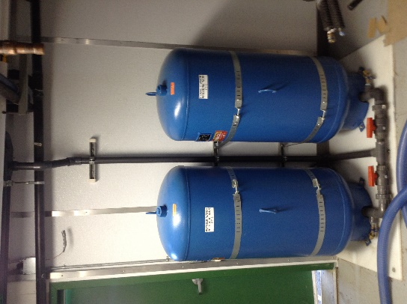

Containers
Barrels, bottles, jugs, etc. are all examples of holding devices. If drinking water will be held for an extended period of time, it should be a container that includes a cover that will prevent airborne or falling contaminants from entering the water. These devices and covers should be constructed of material that will not leak or leach into the water with time. Glass, stainless steel, porcelain, ceramic and some plastics are good materials for this purpose.

If water is to be extracted in single use quantities, an outlet at the bottom should be available to control the release of water without exposing the remaining water to possible contaminants. This avoids the need to dip another item into the water which can easily introduce unseen contaminants into safe drinking water.

If you must use a container that requires dipping to obtain water, keep it covered when the water is not being accessed and always keep the dipping tool far away from any possible contaminants at all times. This includes contact with other items such as insects, animals, hands, used towels, counters, walls, etc. that may harbor contaminates.

Safe Drinking Water Costs
Safe drinking water may take time, effort and even some money. Many times, it may seem to be a boring, inconvenient or troublesome process. In reality, the cost of ensuring safe drinking water quality is quite small and usually need only occur at periodic intervals. When put in perspective, the investment is minimal and the return can be quite substantial. Your communities health and the health of your family and friends requires adequate safe drinking water.

Contaminated Drinking Water Costs
The cost of safe drinking water is easily calculated in measurements of time, effort and money. The cost of contaminated drinking water may be much higher and more difficult to calculate. How much is your health and safety worth?

For example, one encounter with Beaver Fever may require emergency transportation to a medical facility, treatment with antibiotics and rehydration therapy, days in the hospital, more time at home in bed for recovery, loss of income and productivity, misery, pain, suffering, etc. The list could go on. Now, multiply that “cost” by the number of people served by that water.

Different contaminants affect one’s health differently. Many health effects are permanent. Potential effects of contaminated drinking water include cancer, permanent damage to organs (brain, skin, eyes, liver, kidneys, heart, lungs, thyroid gland, stomach, etc.), permanent systemic damage (reproductive system, immune system, nervous system, circulatory system, digestive system, etc.), hair loss and fingernail loss.

Some pay the ultimate price for using contaminated drinking water, life itself. Infants, children, elderly and anyone with a compromised immune system (those suffering from illness) are at the greatest risk of damage from contaminated water. It becomes quite clear that the cost of safe drinking water is much lower than the eventual cost of unsafe drinking water.

Now, Pass it on!
To your family, friends, neighbors and community.
Adequate safe drinking water is everyone Responsibility.
Water is Essential to Life

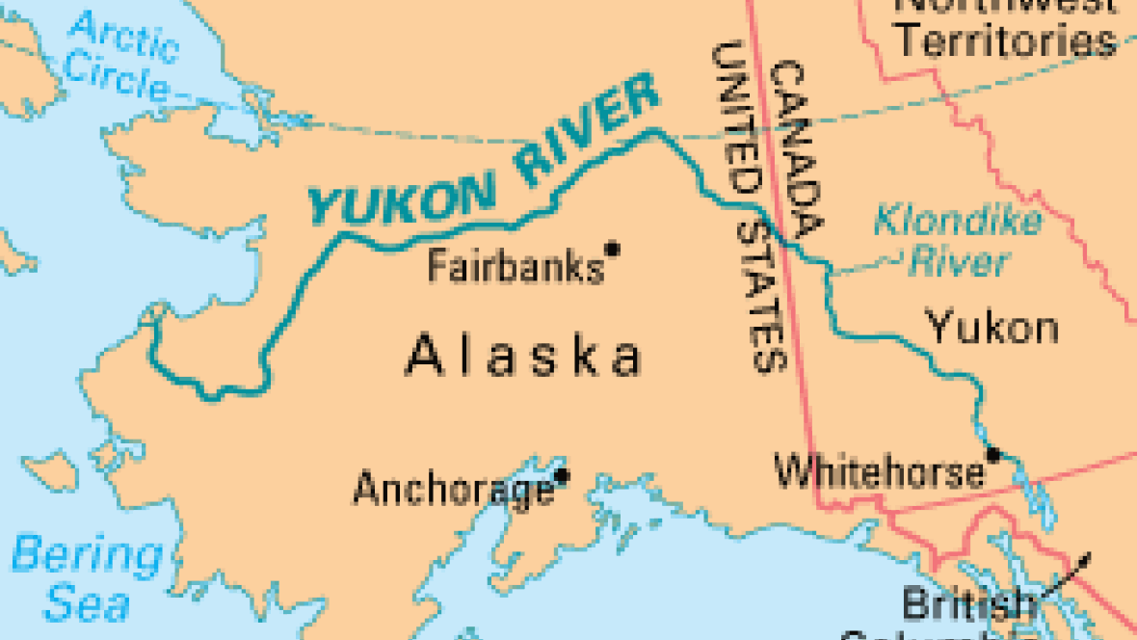

Save our future, preserve our past, protect the infirm and live well.

More Information

If you desire more information regarding adequate safe drinking water, here are a few of the many good web sites available to begin your quest for knowledge.

Alaska Department of Environmental Conservation
http://www.dec.state.ak.us/
DEC-Drinking Water Program Main webpage:
http://dec.alaska.gov/eh/dw/index.htm

DEC-Drinking Water Watch:
http://dec.alaska.gov/DWW/

Drinking Water Program-Fairbanks Compliance Contacts:
1-800-770-2137
1-907-451-2108

DEC-Drinking Water Program General contacts all regions
http://dec.alaska.gov/common/index.htm#dw

Drinking Water Program Engineering Contacts:
http://dec.alaska.gov/eh/docs/dw/Engineering%20Forms/DWEng-Contacts.pdf

Environmental Protection Agency
http://www.epa.gov/

World Health Organization (English language)
http://www.who.int/en/

Service providers for the community can provide vital information by contacting them.
Alaska Native Tribal Health Consortium, Clean Water & Sanitation
4000 Ambassador Drive
Anchorage, Alaska 99508
(907) 729-1900
Web site: anthc.org

Tanana Chief Conference (TCC)
122 1st Avenue
Fairbanks, Alaska 99701
(907) 452-8251
Web site: tananachiefs.org

History of Safe Drinking Water Manual
  - Original Manual created August 13, 2013, Safe Drinking Water Practices Manual
  - Manual revised and renamed, August 2016, Safe Drinking Water and Sanitary Practices Manual
  - Manual revised FY 17, Risk and Threats
  - Manual revisions FY18, to include fact sheets
  - Manual revision FY19, added BIA Schools, old abandoned fuel tanks (risk from flaking lead paint)

