SHIPMENT OF FREON REFRIGERANT GAS TANK AND EQUIPMENT.

Shipment of Freon Refrigerant gas tank and equipment. Refrigerant gas is a Division 2.2 – Non-Toxic, non-flammable gas. A material or mixture that exerts in the packaging an absolute pressure of 280 kPa (40.6 psi =Pounds Per Square Inch) or greater at 20 degrees Celsius or 68 degrees Fahrenheit and does not meet the definition of 2.1 which is flammable or 2.3 which is Poisonous gas. Placards and labels to use is the NON-FLAMMABLE GAS.

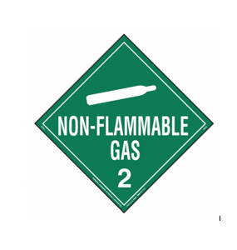

Safety Data Sheets for shipping Freon Kit. The airline you choose for your transporter for sending the kit will have a SDS sheet. It is a form that you will need to fill out before it is sent out. Ask your airline carrier for their “Shippers Declaration Form”

